

**SOFTWARE REQUIREMENT SPECIFICATION**

**<<Extra Learning Centre – ELC01>>**

– Hanoi, June 2025 –

(link video: <https://drive.google.com/drive/folders/16gTcEdAjqImWIsxzoTtwLp1ldvZgwwRO>)

(link figma: <https://www.figma.com/design/PXui29YgjBYOWcnCvU0ndx/Untitled?node-id=0-1&p=f&t=SGFeBdA9UOWBxWOB-0>)

# Record of Changes

| **Version** | **Date** | **A* M, D** | **In charge** | **Change Description** |
| --- | --- | --- | --- | --- |
| V1.0 | 11/06 | A | TrungDQ | Use Case, Actor,Business Rule, Screen Flow |
| V1.0 | 11/06 | A | HoangVM | Use Case, Actor,Business Rule |
| V1.0 | 11/06 | A | ChuVV | Use Case, Actor,Business Rule |
| V1.0 | 11/06 | A | DoTH | Use Case, Actor,Business Rule |
| v1.0 | 11/06 | A | MaiBN | Use Case, Actor,Business Rule |
|  |  |  |  |  |
|  |  |  |  |  |
|  |  |  |  |  |
|  |  |  |  |  |
|  |  |  |  |  |
|  |  |  |  |  |
|  |  |  |  |  |
|  |  |  |  |  |

*A - Added M - Modified D - Deleted

Table of Contents

Record of Changes 2

I. Product Overview 5

1.1. Product Vision 5

1.2. Product Context 5

1.3. Major Features 5

1.4. User Requirements 7

1.4.1 Actors List 7

1.4.2 Use Cases 9

1.5. Assumptions & Dependencies 15

1.6. Limitations and Exclusions 15

1.7. Business Rules 16

II. Use Case Specifications 17

2.1. User Registration 17

2.1.1 UC-01_Register for a Student Account 17

2.1.2 UC-02_Forgot password 18

2.2 Class enrollment 19

2.2.1 UC-44_Enroll in a class 19

2.3. Public Feature 20

2.3.1 UC-03_View Home Page 20

2.3.2 UC-04_View Course Lists 21

2.3.3 UC-05_View Class List 22

2.3.4 UC-06_View Learning Materials …………………………………………………………………….22

2.3.5 UC-07_View Post 22

2.3.6 UC-08_View Information 22

2.4. Manage Courses 24

2.4.1 UC-09_Create Course 24

2.4.2 UC-10_Update Course 25

2.4.3 UC-11_Delete Course 26

2.4.4 UC-12_ Create Class 27

2.4.5 UC-13_ Update Class 29

2.4.6 UC-14_ Delete Class 30

2.5. Manage Accounts 32

2.5.1 UC-15_ View Admin Dashboard 32

UC-15_View Admin Dashboard 32

2.5.2 UC-16_ View Account List 33

UC-16_View Account List 33

2.5.3 UC-17_ View Account Details 35

UC-17_View Account Details 35

2.5.4 UC-18_ Disable/Enable Account 36

UC-18_Disable/Enable Account 36

2.5.5 UC-19_ Update Information of Account 37

UC-19_Update Information of Account 37

2.5.6 UC-22_View Student Class 44

UC-2_View Student Class 44

2.5.7 UC-23_Update Student Class 47

UC-23_Update Student Class 47

2.5.8 UC-24_View Student Tuition 49

UC-19_View Student Tuition 49

2.5.9 UC-20_View Teacher List 50

UC-20_View Teacher List 50

2.6.0 UC-21_Update Teacher Information 52

UC-21_Update Teacher Information 52

2.6.1 UC-22_View Class of Teacher in EL CENTRE 54

UC-22_View Class of Teacher in EL CENTRE 54

2.6.2 UC-23_Update Class of Teacher in EL CENTRE 55

UC-23_Update Class of Teacher in EL CENTRE 55

2.6.3 UC-24_Send Notification to Teacher or Student 57

UC-24_Send Notification to Teacher or Student 57

2.6.4 UC-25_Send Notification to All Members in Class 59

UC-25_Send Notification to All Members in Class 59

2.6.5 UC-26_View Teacher Dashboard 61

UC-26_View Teacher Dashboard 61

III. Functional Requirements 39

3.1. System Functional Overview 39

3.1.1 Screens Flow 39

3.1.2 Screen Descriptions 39

3.1.3 Screen Authorization 39

3.1.4 n-Screen Functions 40

3.2. Data model 40

3.2.1 Entity class diagram 40

3.2.2 Entity Description 40

3.3.1 HomePage 41

1.1.1 HomePage 1.1 41

1.1.2 HomePage 1.241

1.1.3 HomePage Course41

1.1.4 HomePage Materials41

1.1.5 HomePage Post41

1.1.6 HomePage Introduction41

3.3.2 System Administrator41

2.2.1 Admin Dashboard41

2.2.2 Manage Account41

2.2.3 Manage Teacher41

2.2.4 Manage Student41

2.2.5 Manage Course41

2.2.6 Add Course41

2.2.7 Update Course41

2.2.8 Manage Classes41

2.2.9 Add Class41

2.2.10 Update Class41

2.2.11 View Class Information41

3.3.3 Student41

3.1.1 Student Dashboard 41

3.1.2 Student enroll class 41

3.1.3 Student Change Class 41

3.1.4 Student view attendance 41

3.3.4 System Teacher41

4.1.1 Teacher Dashboard 41

IV. Non-Functional Requirements 42

4.1. External Interfaces 42

4.2. Quality Attributes 42

4.2.1 Usability 42

4.2.2 Reliability 42

4.2.3 Performance 42

4.2.4 … 42

# I. Product Overview

## 1.1. Product Vision

For **K-12 tutoring centers and their communities**, who **need an efficient, unified way to manage operations, communication, and student learning**, the **ELCenter (ELC) platform** is a **comprehensive educational management system** that **connects administrators, staff, teachers, students, and parents into a single ecosystem, streamlining daily tasks, improving collaboration, and enabling data-driven decisions**.

Unlike **traditional manual processes or basic management tools**, our product **offers an all-in-one, scalable solution designed specifically for the needs of modern tutoring centers, with user-friendly interfaces, role-based access, and a roadmap for continuous updates and educational integrations**.

## 1.2. Product Context

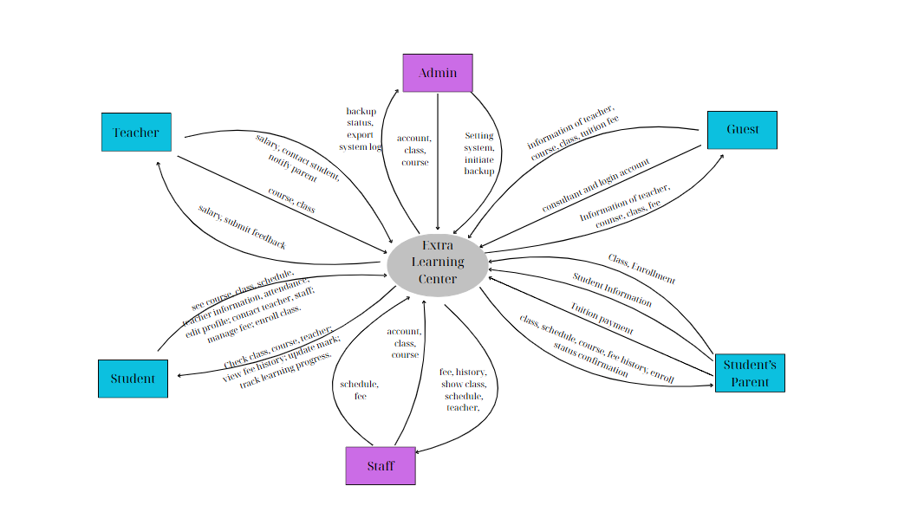

## 1.3. Major Features

* Features-01: Manage user accounts and permissions for different user roles, including administrators, staff, teachers, students, and parents.
* Features-02: Allow all users, including students, staff, teachers, and parents, to view and edit their own profile information to ensure it remains current.
* Features-03: Enable administrators and staff to create, manage, and schedule courses and classes, including filtering and viewing detailed class information.
* Features-04: Allow staff to manage student enrollment by viewing class rosters, assigning students to classes, and updating their information.
* Features-05: Provide tools for staff and teachers to input, update, and track student scores and academic performance.
* Features-06: Enable staff and teachers to record, view, and manage daily student attendance, including the ability to correct records.
* Features-07: Provide a central portal for announcements and stakeholder communication, allowing users to view schedules and progress updates.
* Features-08: Generate reports on student academic progress for parents and students, and operational reports for administrative decision-making.
* Features-09: Allow staff to set course fees and track the payment status of students to manage center financials.
* Features-10: Provide secure, web-based platform access for all users with role-specific permissions that tailor the user experience.

## 1.4. User Requirements

### 1.4.1 Actors List

| **#** | **Actor** | **Description** |
| --- | --- | --- |
| 1 | Administrator | The system administrator is a single individual responsible for overseeing the technical and operational aspects of the system**.** This role involves logging in/out, managing administrator profiles, configuring system settings, and maintaining user accounts for staff, students, and teachers. The administrator also supervises academic content (courses, classes, schedules, attendance, tuition), manages communication content (such as blogs), monitors system activity logs. This role ensures the overall stability, security, and smooth functioning of the platform. |
| 2 | Staff | The system operator (Staff) is responsible for the day-to-day operation and management of the tutoring center (2 members). A Staff member can log in/out, create courses and classes, assign teachers and students to classes, schedule class sessions, manage blogs and manage class’s tuition fee records. Additionally, they can monitor student attendance, academic performance, and generate operational reports. Staff members act as the primary users responsible for the smooth operation of the center under the technical supervision of the system administrator. |
| 3 | Teacher | Teachers have the ability to propose the creation of new classes, including one-on-one sessions or group classes (1-many), based on either student learning requests or their own subject offerings. These proposals are submitted through the system and require review and approval by the system operator (Staff). In addition, teachers are responsible for delivering lessons and monitoring student academic performance in the classes officially assigned to them. A teacher can log in/out, view their teaching schedule, access class rosters, take attendance, enter grades, and provide academic feedback for each student. While teachers can initiate class proposals, they do not have direct permission to manage student accounts, approve enrollments, or configure system-level settings outside of their teaching scope. |
| 4 | Student | Students are the main learners of the center. A student can log in/out to access their personal dashboard, which includes class schedules, attendance history, and learning results. Students can view grades, send teacher feedback, and tuition payment status. They cannot modify any system data, but can monitor their learning progress and stay informed about their learning path and send the request support privately. |
| 5 | Std’s Parent | Parents are linked to one or more students and serve as key supporters of their children's academic journey. A parent can log in/out to view each child’s class schedule, attendance records, academic performance, and tuition payment history. In addition to viewing information, parents can actively enroll their children in available courses, including regular classes or special sessions offered by teachers. However, parents do not have permission to modify student accounts or system settings directly — their access is limited to monitoring, decision-making related to enrollment and payments, and communication support. |
| 6 | Guest | A Guest is an unregistered user who can explore the center by viewing its introduction, browsing available courses with descriptions, schedules, and tuition fees, reading blog posts on knowledge or study tips, and registering for an account to become an official student. |

### 

### 

### 

### 

### 

### 

### 

### 

### 

### 

### 

### 

### 

### 1.4.2 Use Cases

1.4.2.1 Diagram Ucs for Guest:

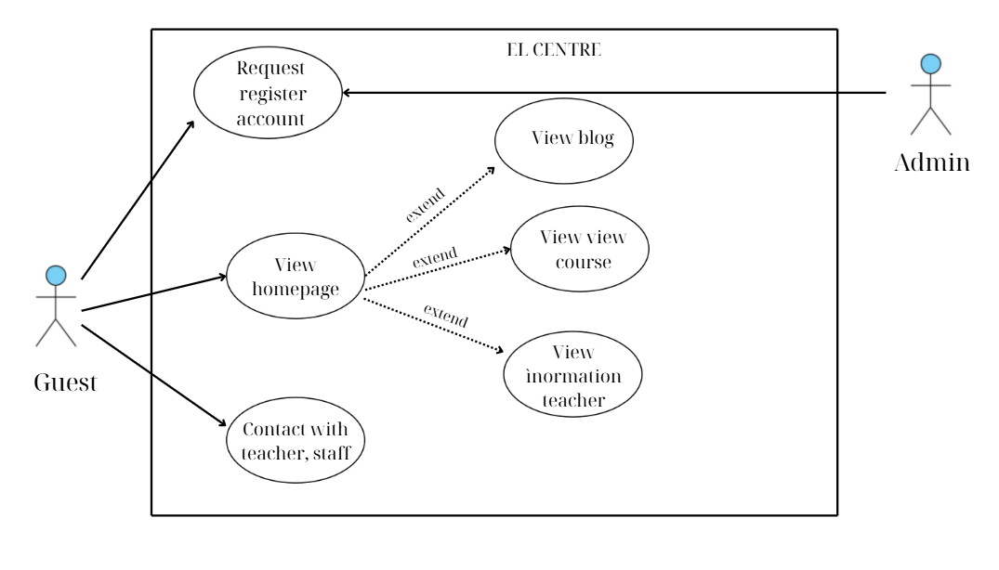

1.4.2.2 Diagram Ucs for Admin:

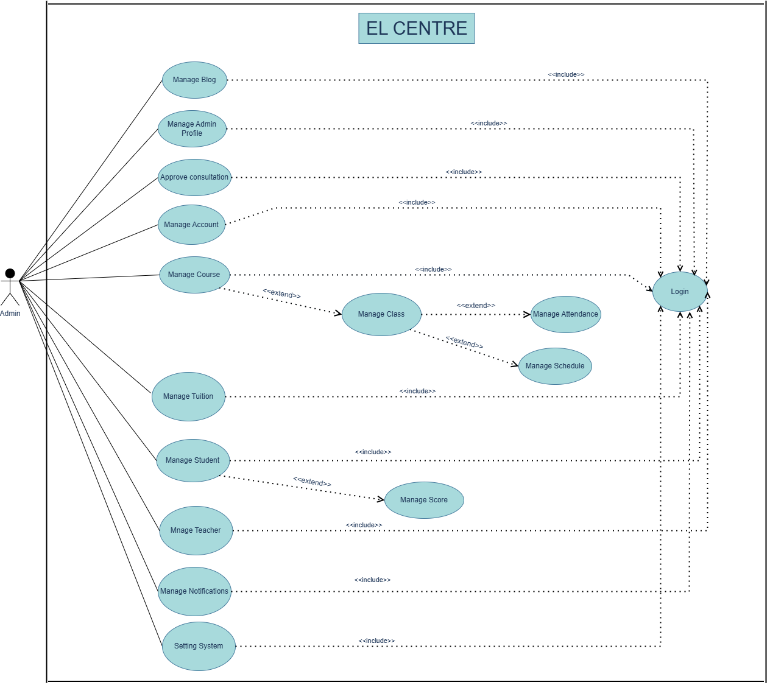

1.4.2.3 Diagram UCs for Staff

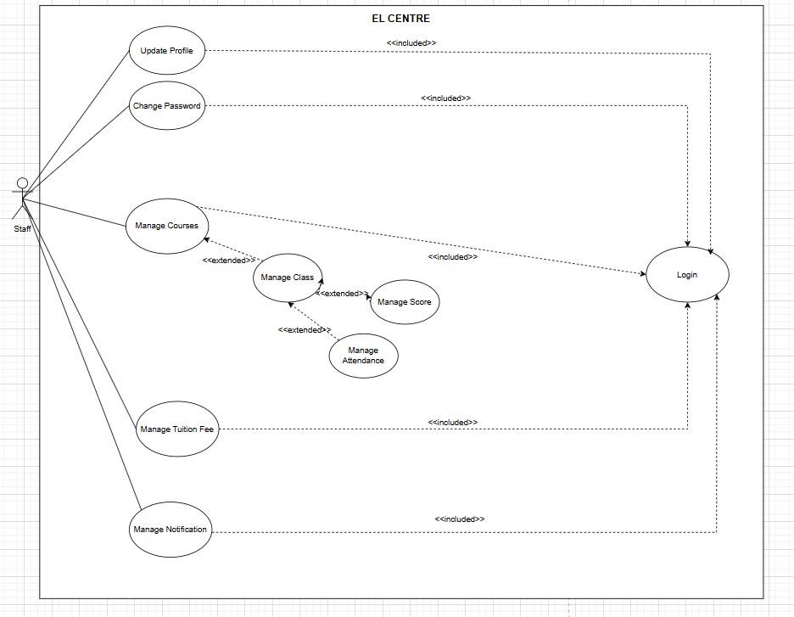

1.4.2.4 : Diagram UCs for Teacher:

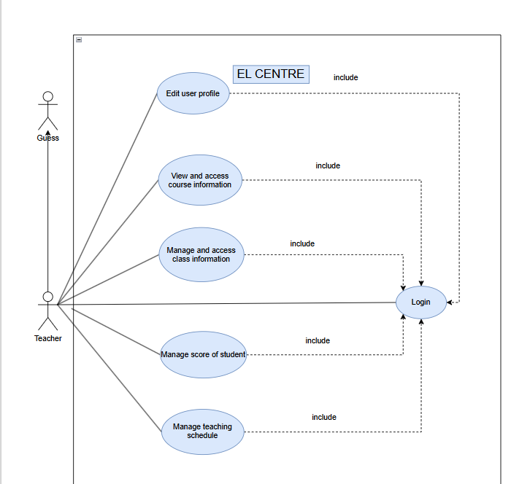

1.4.2.5 : Diagram UCs for Student:

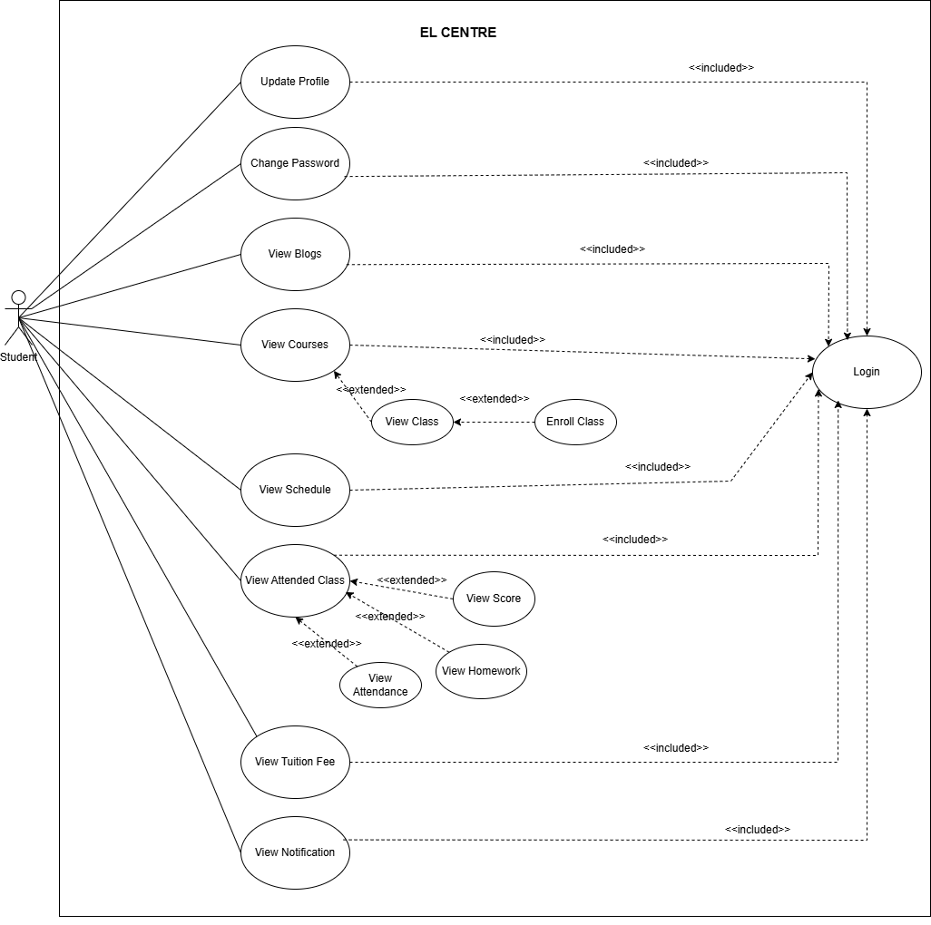

1.4.2.6 : Diagram UCs for Parent:

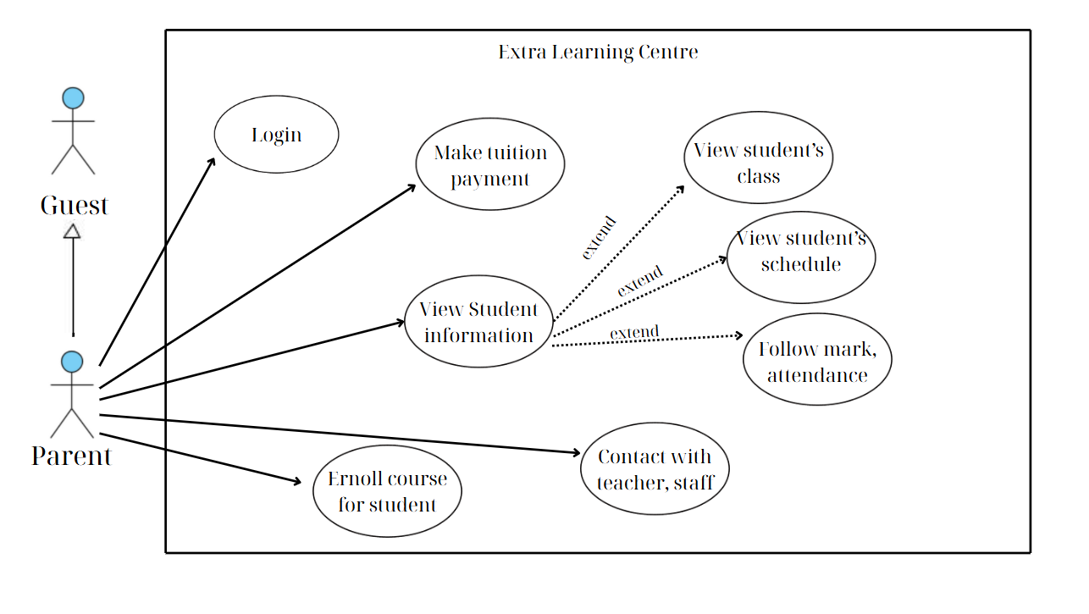

In which

| **ID** | **Feature** | **Use Case** | **Description** |
| --- | --- | --- | --- |
| UC-01 | Public | Register for a Student Account | As a guest user, I want to register for an official student account, so that I can access the educational services provided by the extra study center. |
| UC-02 | Public | Forgot Password | As a user, I want to reset my password via email verification, so that I can securely regain access to my account. |
| UC-03 | Public | View Home Page | As a user, I want to access the main landing page, so that I can navigate the extra learning centre website. |
| UC-04 | Public | View Course Lists | As a user, I want to view a list of available courses, so that I can explore learning options. |
| UC-05 | Public | View Class Lists | As a user, I want to view all available classes, so that I can learn more about their schedules and details. |
| UC-06 | Public | View Learning Materials | As a user, I want to access learning materials, so that I can preview or download content to support my education. |
| UC-07 | Public | View Post | As a user, I want to read posts and announcements, so that I can stay updated with centre news and events. |
| UC-08 | Public | View Centre’s information | *As a user, I want to view centre information, so that I can understand its services, location, and policies.* |
| UC-9 | Admin, Staff | Create course | *As an admin or staff, I want to create new courses, so that students can enroll in them.* |
| UC-10 | Admin, Staff | Update Course | As an admin or staff, I want to update course information, so that details stay accurate and up-to-date. |
| UC-11 | Admin, Staff | Delete Cours**e** | *As an admin or staff, I want to delete courses, so that outdated or cancelled courses are removed from the system.* |
| UC-12 | Admin, Staff | Create Class | *As an admin or staff, I want to create new classes, so that students can be assigned to appropriate learning groups.* |
| UC-13 | Admin, Staff | Update Class | As an admin or staff, I want to update class details, so that information like size, schedule, or fee is correct. |
| UC-14 | Admin, Staff | Delete Class | As an admin or staff, I want to delete classes, so that unnecessary or duplicate entries are removed. |
| UC-15 | Admin | View Admin Dashboard | *As an admin, I want to view a dashboard, so that I can monitor system statistics, logs, and daily schedules.* |
| UC-16 | Admin | View Account List | *As an admin, I want to view all user accounts, so that I can manage and monitor user activity.* |
| UC-17 | Admin | View Account Details | As an admin, I want to see detailed information of each user, so that I can verify and manage accounts. |
| UC-18 | Admin | Disable/Enable Account | As an admin, I want to enable or disable accounts, so that I can control system access. |
| UC-19 | Admin | Update Information of Account | As an admin, I want to update user account details, so that their information remains current and accurate. |
| UC-20 | Admin, Staff | View Student List | As an admin or staff, I want to view all enrolled students, so that I can manage and monitor student data. |
| UC-21 | Admin, Staff | Update Student Information | As an admin or staff, I want to update student information, so that their records stay accurate. |
| UC-22 | Admin, Staff | View Student Class in EL CENTRE | As an admin or staff, I want to view a student’s enrolled classes, so that I can track their academic journey. |
| UC-23 | Admin, Staff | Update Student Class in EL CENTRE | As an admin or staff, I want to update a student’s class enrollment, so that it reflects changes in their schedule. |
| UC-24 | Admin, Staff | View Student Tuition | As an admin or staff, I want to view student tuition information, so that I can track payments and dues. |
| UC-25 | Admin, Staff | View Teacher List | As an admin or staff, I want to view all teachers, so that I can manage their profiles. |
| UC-26 | Admin, Staff | Update Teacher Information | As an admin or staff, I want to update teacher details, so that their information remains up-to-date. |
| UC-27 | Admin, Staff | View Class of Teacher in EL CENTRE | As an admin or staff, I want to view the classes assigned to each teacher, so that I can manage workload and schedules. |
| UC-28 | Admin , Staff | Update Class of Teacher in EL CENTRE | *As an admin or staff, I want to assign or reassign teacher classes, so that schedules match expertise and availability.* |
| UC-29 | Admin , Staff | Send Notification to Teacher or Student | As an admin or staff, I want to send notifications to individual users, so that they receive important updates. |
| UC-30 | Admin , Staff | Send Notification to All Member in Class | As an admin or staff, I want to notify all members in a class, so that everyone stays informed. |
| UC-31 | Teacher | View Teacher Dashboard | As a teacher, I want to view my dashboard, so that I can monitor classes and teaching schedules. |
| UC-32 | Teacher | View Teaching Schedule | *As a teacher, I want to see my teaching schedule, so that I can stay organized.* |
| UC-33 | Teacher | View Salary | As a teacher, I want to view salary details, so that I can track payments and bonuses. |
| UC-34 | Teacher | View Attended Class | As a teacher, I want to view my attended classes, so that I can monitor my teaching activity. |
| UC-35 | Teacher | View Student in Class | *As a teacher, I want to view students in my class, so that I can support their learning better.* |
| UC-36 | Teacher | Manage Assignment | *As a teacher, I want to manage assignments, so that students have clear tasks and deadlines.* |
| UC-37 | Teacher | View Attendance | As a teacher, I want to view attendance records, so that I can monitor student participation. |
| UC-38 | Student | Request change class | As a student, I want to request a class change, so that I can switch if needed. |
| UC-39 | Student, Parent | View schedule | As a student, I want to view my class schedule, so that I can attend on time. |
| UC-40 | Student, Parent | View tuition | As a student, I want to see my tuition information, so that I can manage my payments. |
| UC-41 | Student, Parent | View attendance | *As a student, I want to view my attendance records, so that I can track my participation.* |
| UC-42 | Student, Parent | View notification | *As a student, I want to view notifications, so that I stay informed about updates.* |
| UC-43 | Student | Submit assignment | As a student, I want to submit assignments, so that my work is evaluated. |
| UC- 44 | Student | Enroll in a class | *As a student, I want to enroll in a class, so that I can begin learning.* |

## 1.5. Assumptions & Dependencies

AS-1: All users (students, parents, teachers, staff) are expected to have access to a computer and a stable internet connection to use the web-based system effectively.

AS-2: The center will have sufficient operational staff to manage daily activities, including class scheduling, teacher assignment, tuition tracking, and report generation.

AS-3: All user data will be entered accurately and completely during account creation or updates or forgotten password to ensure the reliability of system functions.

AS-4: The online payment system will remain stable and functional to allow students and parents to pay tuition fees securely and on time.

AS-5: In order for users to navigate and make use of the features provided by the Extra Learning Centre website, a basic level of computer literacy is assumed.

AS-6**:** The system is online and the server is operational during the course creation process.  
AS-7**:** The course creation form is fully loaded and rendered correctly in the user’s browser.

AS-8: The course being updated exists in the system and is identifiable by a valid Course ID.  
AS-9: The Admin or Staff has appropriate permissions to perform course updates.

AS-10: The center has an online database for account storage.

AS-11: Email/SMS notification service is available and configured properly.

AS-12: Class data is updated in real time.

AS-13: Tuition payment verification may be integrated later.

AS-15: Upload directory exists and writable

AS-16: Valid class ID provided

AS-17: Staff is aware of dependencies

DE-1: The system depends on the availability and performance of third-party online payment gateways (e.g., VNPay, Momo). Any downtime or issues with these services may affect the tuition payment process.

DE-2: System maintenance and technical issue resolution rely on the availability of external developers or IT service providers, as the center does not have dedicated in-house technical staff.

DE-3: The web application must be hosted on a reliable server or hosting platform to ensure system uptime and responsive performance for all users

## 1.6. Limitations and Exclusions

* The system only supports access via web browsers and does not include mobile applications for iOS or Android at this stage.
* The system does not support integration with external platforms such as Learning Management Systems (LMS), online meeting tools (Zoom, Microsoft Teams), or online payment gateways (PayPal, Stripe).
* The system does not offer online learning features such as video conferencing or academic interaction tools (forums, online quizzes).
* The system does not provide predictive analytics, AI-powered features, or trend reports to support decision-making.

## 1.7. Business Rules

| **ID** | **Category** | **Rule Definition** |
| --- | --- | --- |
| BR-01 | Constraints | Only one student account can be registered per email address. |
| BR-02 | Constraints | Password must contain at least 8 characters, including a number and  a special symbol. |
| BR-03 | Constraints | A student can’t enroll in the same class twice. |
| BR-04 | Constraints | Course name must be unique in the system |
| BR-05 | Constraints | Students, Learners can view courses, classes, classes' details, search/filter courses,view/ search classes, view feedback, view blogs and centre’s information. |
| BR-06 | Constraints | A course can only be deleted if it has no linked classes. |
| BR-07 | Constraints | When adding a class, uploaded image must be in JPG or PNG format and less than 5MB in size |
| BR-08 | Constraints | Class updates must preserve existing links (e.g., to courses or schedules); name, time, and fee must be valid. |
| BR-09 | Constraints | A class can only be deleted if it has no dependent data like enrolled students or payment records |
| BR-10 | Constraints | Network transmissions that involve financial information or personally identifiable information require 256-bit encryption. |
| BR-11 | Constraints | Only regular employees can register for payroll deduction for any company purchase. |
| BR-12 | Constraints | Only admins have access to the admin dashboard |
| BR-13 | Constraints | Disabled accounts are not allowed to log in. |
| BR-14 | Constraints | Only admin is allowed to update information, enable/disable user accounts. |
| BR-15 | Constraints | When creating an account, you must provide complete information such as: Full name, email, role, phone number, address,.... |
| BR-16 | Constraints | Only active admin account (not disabled) can access the dashboard |
| BR-17 | Constraints | Parents can only view the profiles of their linked childe |
| BR-18 | Action Enablers | Teachers can only upload documents for their assigned classes |
| BR-19 | Action Enablers | Parent can allowed to view their children's attendance and grades |
| BR-20 | Constraints | Students, Learners can view courses, courses' details, search/filter courses,view feedback |
| BR-21 | Action Enablers | When a student successfully enrolls in a class, an action to send a confirmation email to the student's registered address must be triggered. |
| BR-22 | Inference | A student's "Completed" status for a course shall be inferred as true only when all mandatory exams and assignments for that course have a passing grade. |
| BR-23 | Facts | Each user account belongs to exactly one of these roles: Admin, Staff, Teacher, Student, Parent. |
| BR-24 | Facts | Each student may have zero, one, or two parents linked to their account. |
| BR-25 | Action Enablers | If a class is cancelled, the system must automatically notify all enrolled students and their parents. |
| BR-26 | Action Enablers | When a teacher submits an assignment, the system must automatically update the student's assignment in the dashboard. |
| BR-27 | Inference | If a student’s attendance rate for a class falls below 80%, the system marks the student as "At Risk" for that class. |
| BR-28 | Inference | If a parent account has no active children, their access is limited to center announcements. |
| BR-29 | Computation | The total tuition for a student in a term equals the sum of all enrolled class fees minus any valid discounts. |
| BR-30 | Computation | The system calculates each teacher’s total teaching hours per week as the sum of all scheduled class sessions. |

# II. Use Case Specifications

# 2.1. User Registration

### 2.1.1 UC-01_Register Account

| ID and Name: | **UC-01 Register Account** | | |
| --- | --- | --- | --- |
| Created By: | MaiBNHE182269 | Date Created: | 15/06/2025 |
| Primary Actor: | Guest | Secondary Actors: |  |
| Description: | A guest visits the website of the extra study center and wants to create an official student account to access educational services. The system guides them through the registration form, verifies the information, and creates an account upon successful validation. | | |
| Trigger: | A guest selects the “Register” option on the homepage. | | |
| Preconditions: | PRE-1. The guest has a valid internet connection and device.  PRE-2. The guest has not previously registered with the same email address or phone number. | | |
| Postconditions: | POST-1. A new student account is created and stored in the system.  POST-2. The student is redirected to the login page with a success message.  POST-3. The account is set to “Active” and ready for login. | | |
| Normal Flow: | 1. Guest clicks “Register for an Account” on the homepage. 2. The system displays the registration form with required fields: full name, email, phone number, password, etc. 3. Guest enters the required information. 4. System validates the input (e.g., required fields, password strength). 5. System checks for duplicate email or phone. 6. Guest confirms and submits the form. 7. The system creates the account in the database. 8. System sends a confirmation email and/or SMS to the guest 9. The system redirects guests to login page with a success message. | | |
| Alternative Flows: | 1.1 Guest enters duplicate email → System displays “Email already in use” and requests a new one.  1.2 Guest enters weak password → System highlights issue and requests a stronger one. | | |
| Exceptions: | 1.0.E1 – Guest leaves required fields empty → System highlights missing fields and halts progress.  1.0.E2 – Email/SMS sending fails → System shows alert but completes account creation. | | |
| Priority: | High | | |
| Frequency of Use: | Dozens of new users per week (peak during admissions seasons). | | |
| Business Rules: | BR-01, BR-02 | | |
| Other Information: | Guests may cancel the registration at any time before submitting.  Confirmation via email/SMS is optional based on system settings. | | |
| Assumptions: | AS-10, AS-11 | | |

### 2.1.2 UC-02_Forgot password

### 

| ID and Name: | **UC-02 Forgot password** | | |
| --- | --- | --- | --- |
| Created By: | DoTHHE182087 | Date Created: | 15/06/2025 |
| Primary Actor: | Student, Teacher, Staff, Parent | Secondary Actors: | Admin |
| Description: | Guests who go to the system who want to log in but do not remember their password will be directed to the forgot password section. There they are required to enter the correct Email and Phone Number registered with their account to allow them to change their password. | | |
| Trigger: | A guest selects the “Forgot password” option login option. | | |
| Preconditions: | PRE-1. The user has access to a stable internet connection and a compatible device.  PRE-2. The user has previously registered with a valid email address or phone number.  PRE-3. The user accesses the “Forgot Password” page from the system's login interface. | | |
| Postconditions: | POST-1. Check valid email and phone if wrong so guest can not change password  POST-2. The system verifies the request and allows the user to reset their password.  POST-3. A success message is shown, and the user is redirected to the login page. | | |
| Normal Flow: | 1. The visitor clicks “Forgot Password” on the login page.  2. The system displays a verification form with required fields for verification: Email, phone number.  3. The visitor enters the required information.  4. The system validates the input information (e.g. required fields, password strength).  5. The system checks for duplicate emails or phone numbers.  6. The system allows the user to enter a new password  7. The system redirects the visitor to the login page with a success message. | | |
| Alternative Flows: | 1.1 The guest enters an incorrect email or phone number or one that does not exist in the system → The system displays “Incorrect or non-existent email! Please try again”, or “Incorrect or non-existent phone number in the system” depending on which is incorrect, checks from email to phone number and creates a new entry request.  1.2 The guest enters a new password that is not in the allowed format → The system highlights the problem and requests a suitable or stronger password. | | |
| Exceptions: | 1.0.E1 – Guest leaves required fields blank → System marks missing fields and stops the process.  1.0.E2 – Send notification failed → System displays warning and password is not changed | | |
| Priority: | High | | |
| Frequency of Use: | Dozens of new users per week (peak during admissions seasons). | | |
| Business Rules: | BR-02 | | |
| Other Information: | Guests can choose to forget their password at any time, whether it is because they forgot it or want to change it to a new one without logging into the system. | | |
| Assumptions: | AS-3 | | |

### 2.2 Class enrollment

### 2.2.1 UC-44_Enroll in a class

| ID and Name: | **UC-44 Enroll in a Class** | | |
| --- | --- | --- | --- |
| Created By: | MaiBNHE182269 | Date Created: | 15/06/2025 |
| Primary Actor: | Student | Secondary Actors: | Staff |
| Description: | A student (or parent on behalf of the student) logs into the system, views available classes, and selects a class to enroll in. The system checks for availability and enrolls the student if the class is not full. | | |
| Trigger: | Student/Parent selects the “Enroll in Class” option from their dashboard. | | |
| Preconditions: | PRE-1. Student or Parent is logged in.  PRE-2. The student is eligible for enrollment (e.g., has no payment issues). | | |
| Postconditions: | POST-1. The student is successfully enrolled in the selected class.  POST-2. The class roster is updated.  POST-3. A confirmation message is sent to the student/parent. | | |
| Normal Flow: | 1. Student/Parent clicks “Enroll in Class.” 2. The system displays the list of available classes with filters (subject, time, teacher, level). 3. Student/Parent selects a class. 4. The system checks if the class has available slots. 5. If available, the system enrolls the student. 6. The system sends confirmation via dashboard and optional email/SMS. 7. System updates class roster and enrollment statistics. | | |
| Alternative Flows: | 1.1 Student selects multiple classes → System checks each for availability before confirming batch enrollment.  1.2 Parents enrol multiple children in the same class → System processes each separately. | | |
| Exceptions: | 1.0.E1 Class is full → System displays “Class Full” and offers to waitlist or choose another.  1.0.E2 System error in updating class → Displays error message and logs failure.  1.0.E3 Student already enrolled → System notifies with no duplicate enrollment allowed. | | |
| Priority: | High | | |
| Frequency of Use: | High during new term enrollment periods; moderate otherwise. | | |
| Business Rules: | BR-03, BR-04 | | |
| Other Information: | Waitlisting may be implemented in future versions.  Enrollment can be canceled up to 48 hours before class starts. | | |
| Assumptions: | AS-12, AS-13 | | |

## 2.3. Public Feature

### 2.3.1 UC-03_View Home Page

| ID and Name: | **UC-03 View Home Page** | | |
| --- | --- | --- | --- |
| Created By: | Dam Quang Trung | Date Created: | 6/11/2025 |
| Primary Actor: | Guest | Secondary Actors: |  |
| Description: | A customer (or guest) accesses the extra learning website and views the home page, which displays sliders, blog category, a variety of courses, available classes and information about centre | | |
| Trigger: | A guest wants to browse or access for learning centre on the online extra learning website | | |
| Preconditions: | PRE-1: The website can be accessed | | |
| Postconditions: | POST-1: The guest has viewed the home page and is familiar with the sliders, blog category, and a variety of new courses, classes available on the website. | | |
| Normal Flow: | **1.0 Home Page**  1. The guest accesses the extra learning centre website  2. The website display the Home Page | | |
| Alternative Flows: | **2.1 Guest interacts with a course or class**  This flow occurs when the guest actively engages with the content on the home page.   1. At step 2 of the Normal Flow, the home page is displayed successfully. 2. The guest clicks on a specific course or class card being displayed. 3. The system navigates the guest to the corresponding "Course Details" or "Class Details" page. 4. This use case ends and proceeds to use case " View Course Details". | | |
| Exceptions: | ***Unavailable website***  1. If the website is unavailable, the guest will be unable to view the home page | | |
| Priority: | High | | |
| Frequency of Use: | Frequent | | |
| Business Rules: | BR-05 | | |
| Other Information: | The home page should be updated regularly with new classes, courses , slider and blog categories | | |
| Assumptions: | AS-1, AS-5 | | |

### 

### 

### 2.3.2 UC-04_View Course Lists

| ID and Name: | UC-04_View Course Lists | | |
| --- | --- | --- | --- |
| Created By: | Dam Quang Trung | Date Created: | 6/11/2025 |
| Primary Actor: | Guest | Secondary Actor | Student, Parents |
| Description: | A guest or learner accesses the extra learning website and views the courses list. | | |
| Trigger: | A customer wants to browse or access for learning centre on the online extra learning website | | |
| Preconditions: | PRE-1: The website can be accessed | | |
| Postconditions: | POST-1: The customer has viewed a list of new courses and is able to see more or buy course | | |
| Normal Flow: | **1.0 Home Page**  1. The guest accesses the extra learning centre website  2. The website displays a list of courses including course name, grade….. | | |
| Alternative Flows: | **2.1 Filter Courses**  1.Users use the filter bar to choose option filter  2.All courses sorted by filter following the user’s choice will be shown.  **2.2 Search course by name**   1. Users search the name of the course they want to find.   The system will return courses that are relevant to the content they search. | | |
| Exceptions: | ***Unavailable website***  1. If the website is unavailable, the guest will be unable to view the home page | | |
| Priority: | High | | |
| Frequency of Use: | Frequent | | |
| Business Rules: | BR-20 | | |
| Other Information: | The list of courses should be updated regularly with new courses and deleted out-of-date courses | | |
| Assumptions: | AS-1, AS-5 | | |

### 2.3.3 UC-05_View Class List

### 

| ID and Name: | UC-05_View Class List | | |
| --- | --- | --- | --- |
| Created By: | DoTHHE182087 | Date Created: | 6/15/2025 |
| Primary Actor: | Guest | Secondary Actor | Student, Staff |
| Description: | Guests or learners access the supplemental learning website and view the class listings. | | |
| Trigger: | When learners click to view a specific course, the screen will be redirected to the page listing specific classes of that course. | | |
| Preconditions: | PRE-1: The user has access to a stable internet connection and a compatible device.  PRE-2: The course being viewed is published and available to the public or to logged-in users (based on role).  PRE-3: The system database contains active class listings for the selected course. | | |
| Postconditions: | POST-1: The user views the list of classes under the selected course.  POST-2: The user can see detailed class information and optionally proceed to registration or inquiry. | | |
| Normal Flow: | 1. The user accesses the Extra Learning Center homepage.  2. The homepage displays a list of available courses (course name, level, subject).  3. The user selects a course of interest.  4. The system displays a list of available classes under the selected course.  5. The user views details such as class name, schedule, available slots, and teacher info. | | |
| Alternative Flows: | 1. Filter Class The user uses the filter bar to choose filter options (e.g., subject, level, date). The system displays only the classes matching the filter criteria.  2. Search class by name The user enters the name of a course into the search bar. The system returns relevant courses and associated class listings matching the search keyword. | | |
| Exceptions: | Unavailable Website   1. If the website is temporarily unavailable due to system maintenance or server error, the user will not be able to access the homepage or course listings. 2. The system shows a message: “The service is currently unavailable. Please try again later.” | | |
| Priority: | High | | |
| Frequency of Use: | Frequent | | |
| Business Rules: | BR-05 | | |
| Other Information: | The list of class should be updated regularly with new class and deleted out-of-date class | | |
| Assumptions: | AS-1, AS-5 | | |

### 2.3.4 UC-06_View Learning Materials

### 

| ID and Name: | UC-06_View Material List | | |
| --- | --- | --- | --- |
| Created By: | TrungDQHE190664 | Date Created: | 7/13/2025 |
| Primary Actor: | Guest | Secondary Actor | Student, Staff |
| Description: | Guests or learners access the supplemental learning website and view the class listings. | | |
| Trigger: | When learners click to view a specific material, the screen will be redirected to the page listing details of that course. | | |
| Preconditions: | PRE-1: The user has access to a stable internet connection and a compatible device.  PRE-2: The material being viewed is published and available to the public or to logged-in users (based on role).  PRE-3: The system database contains active material listings for the selected course. | | |
| Postconditions: | POST-1: The user views the details under the selected material.  POST-2: The user can download the material free. | | |
| Normal Flow: | 1. The user accesses the Extra Learning Center homepage.  2. The homepage displays a list of material (subject, name, description, type).  3. The user selects a material of interest.  4. The system displays a list of available material under the selected subject.  5. The user views details such as subject, name, description, type. | | |
| Alternative Flows: | 1. Filter Material The user uses the filter bar to choose filter options (e.g., subject, level, date). The system displays only the materials matching the filter criteria.  2. Search material by name The user enters the name of a material into the search bar. The system returns relevant materials and associated material listings matching the search keyword. | | |
| Exceptions: | Unavailable Website   1. If the website is temporarily unavailable due to system maintenance or server error, the user will not be able to access the homepage or material listings. 2. The system shows a message: “The service is currently unavailable. Please try again later.” | | |
| Priority: | High | | |
| Frequency of Use: | Frequent | | |
| Business Rules: | BR-05 | | |
| Other Information: | The list of material should be updated regularly with new document and deleted out-of-date material | | |
| Assumptions: | AS-1, AS-5 | | |

### 

### 2.3.3 UC-07_View Post List

### 

| ID and Name: | UC-07_View Post List | | |
| --- | --- | --- | --- |
| Created By: | TrungDQHE190664 | Date Created: | 7/13/2025 |
| Primary Actor: | Guest | Secondary Actor | Student, Staff |
| Description: | Guests or learners access the supplemental learning website and view the Post listings. | | |
| Trigger: | When learners click to view a specific post, the screen will be redirected to the page listing specific details of that post. | | |
| Preconditions: | PRE-1: The user has access to a stable internet connection and a compatible device.  PRE-2: The post being viewed is published and available to the public or to logged-in users (based on role).  PRE-3: The system database contains active post listings. | | |
| Postconditions: | POST-1: The user views the list of posts under the selected keyword.  POST-2: The user can see detailed post information and optionally proceed to registration or inquiry. | | |
| Normal Flow: | 1. The user accesses the Extra Learning Center homepage.  2. The homepage displays a list of available posts (post name, keyword, keyTag,...).  3. The user selects a post of interest.  4. The user views details such as post name, keyword, description, and Content. | | |
| Alternative Flows: | 1. Filter post The user uses the filter bar to choose filter options (e.g., keyword, keyTag, date). The system displays only the classes matching the filter criteria.  2. Search post by name The user enters the name of a post into the search bar. The system returns relevant post and associated post listings matching the search keyword. | | |
| Exceptions: | Unavailable Website   1. If the website is temporarily unavailable due to system maintenance or server error, the user will not be able to access the homepage or post listings. 2. The system shows a message: “The service is currently unavailable. Please try again later.” | | |
| Priority: | High | | |
| Frequency of Use: | Frequent | | |
| Business Rules: | BR-05 | | |
| Other Information: | The list of post should be updated regularly with new class and deleted out-of-date post | | |
| Assumptions: | AS-1, AS-5 | | |

### 

### 

### 2.3.3 UC-08_View Centre’s Information

### 

| ID and Name: | UC-08_View Centre’s Information | | |
| --- | --- | --- | --- |
| Created By: | TrungDQHE190664 | Date Created: | 7/13/2025 |
| Primary Actor: | Guest | Secondary Actor | Student, Staff |
| Description: | Guests or learners access the supplemental learning website and view the class listings. | | |
| Trigger: | When learners click to view information about the centre, the screen will be redirected to the page listing information. | | |
| Preconditions: | PRE-1: The user has access to a stable internet connection and a compatible device.  PRE-2: The information being viewed is published and available to the public or to logged-in users (based on role).  PRE-3: The system database contains active class listings for the information. | | |
| Postconditions: | POST-1: The user views the information.  POST-2: The user can request detailed class information and optionally proceed to registration or inquiry. | | |
| Normal Flow: | 1. The user accesses the Extra Learning Center homepage.  2. The homepage displays information about the centre.  3. The user fills the field to request consultation . | | |
| Alternative Flows: | none | | |
| Exceptions: | Unavailable Website   1. If the website is temporarily unavailable due to system maintenance or server error, the user will not be able to access the homepage or course listings. 2. The system shows a message: “The service is currently unavailable. Please try again later.” | | |
| Priority: | High | | |
| Frequency of Use: | Frequent | | |
| Business Rules: | BR-05 | | |
|  |  | | |
| Assumptions: | AS-1, AS-5 | | |

### 

## 2.4. Manage Courses

### 2.4.1 UC-09_Create Course

| ID and Name: | UC-09_Create Course | | |
| --- | --- | --- | --- |
| Created By: | Vu Minh Hoang | Date Created: | 6/11/2025 |
| Primary Actor: | Admin-Staff | Secondary Actors: | Student, Guest |
| Description: | Admin or Staff accesses the course creation page, fills in required information such as course name, description, schedule, and submits the form to create a new course. | | |
| Trigger: | Admin or Staff wants to add a new course to the system. | | |
| Preconditions: | PRE-1: User is logged in as Admin or Staff  PRE-2: Input data is valid | | |
| Postconditions: | POST-1: A new course is added and displayed in the course list. | | |
| Normal Flow: | **1.0 Create Course**  1. Admin/Staff opens the create course form  2. Fills in course data  3. Submits the form  4. System saves and confirms creation | | |
| Alternative Flows: | **1.1 Invalid Data**  1. System displays error message and asks user to correct the form | | |
| Exceptions: | **Unavailable Database**  1. System cannot connect to database to save course | | |
| Priority: | High | | |
| Frequency of Use: | Frequent | | |
| Business Rules: | BR-04 | | |
| Other Information: | System records timestamp of creation automatically | | |
| Assumptions: | AS-6, AS-7 | | |

### 

### 2.4.2 UC-10_Update Course

| ID and Name: | UC-10_Update Course | | |
| --- | --- | --- | --- |
| Created By: | Vu Minh Hoang | Date Created: | 6/11/2025 |
| Primary Actor: | Admin-Staff | Secondary Actors: | Student, Guest |
| Description: | Admin or Staff selects an existing course and modifies fields like name, description, schedule, or status. | | |
| Trigger: | Admin/Staff needs to change information of an existing course | | |
| Preconditions: | PRE-1: Course exists in the system  PRE-2: User has permission | | |
| Postconditions” | POST-1: Course data is updated successfully | | |
| Normal Flow: | **1.0 Update Course**  **1. Admin/Staff selects a course**  **2. Edits fields**  **3. Submits changes**  **4. System updates course in database** | | |
| Alternative Flows: | **1.1 No changes made**  1. System does not save  2. Shows “no changes detected” | | |
| Exceptions: | **Concurrency Error**  **1. Another user updated the course at the same time** | | |
| Priority: | Medium | | |
| Frequency of Use: | Frequent | | |
| Business Rules: | BR-05 | | |
| Other Information: | System may log the modifier and time | | |
| Assumptions: | AS-8, AS-9 | | |

### 

### 2.4.3 UC-11_Delete Course

| ID and Name: | UC-11_Delete Course | | |
| --- | --- | --- | --- |
| Created By: | Vu Minh Hoang | Date Created: | 6/11/2025 |
| Primary Actor: | Admin-Staff | Secondary Actors: | Student, Guest |
| Description: | Admin or Staff deletes an existing course from the system (can be soft delete or hard delete). | | |
| Trigger: | Admin/Staff wants to remove a course no longer offered. | | |
| Preconditions: | PRE-1: Course exists  PRE-2: User has delete permission | | |
| Postconditions” | POST-1: Course is removed or marked inactive | | |
| Normal Flow: | **1.0 Delete Course**  1. Admin/Staff clicks "delete" on a course  2. System shows confirmation  3. Course is deleted or flagged | | |
| Alternative Flows: | **1.1 Cancel Deletion**  **1. User cancels deletion in confirmation dialog** | | |
| Exceptions: | ***Linked Class Exists***  ***1. System blocks deletion and shows message*** | | |
| Priority: | High | | |
| Frequency of Use: | Occasional | | |
| Business Rules: | BR-06 | | |
| Other Information: | Soft-delete preferred for record keeping | | |
| Assumptions: | AS-9 | | |

### 

### 

### 2.4.4 UC-12_ Create Class

| ID and Name: | UC-12_ Create Class | | |
| --- | --- | --- | --- |
| Created By: | Vu Minh Hoang | Date Created: | 6/11/2025 |
| Primary Actor: | Admin-Staff | Secondary Actors: | Student, Guest |
| Description: | Allows Admin or Staff to add a new class with attributes like name, size, schedule, fee, and image | | |
| Trigger: | A staff wants to add a new class to a course | | |
| Preconditions: | PRE-1: Course exists  PRE-2: User has permission | | |
| Postconditions” | POST-1: Class is created and saved in the system | | |
| Normal Flow: | **1.0 Create Class**  1. Admin/Staff accesses "Add Class" page  2. Fills in required fields  3. Uploads optional image  4. Submits form  5. System saves class | | |
| Alternative Flows: | **1.1 Missing required fields**  **1. System shows validation message** | | |
| Exceptions: | ***File upload fails or invalid format*** | | |
| Priority: | High | | |
| Frequency of Use: | Regular | | |
| Business Rules: | BR-07 | | |
| Other Information: | Class is associated with a course and a grade | | |
| Assumptions: | AS-15 | | |

### 

### 2.4.5 UC-13_ Update Class

| ID and Name: | UC-13_ Update Class | | |
| --- | --- | --- | --- |
| Created By: | Vu Minh Hoang | Date Created: | 6/11/2025 |
| Primary Actor: | Admin-Staff | Secondary Actors: | Student, Guest |
| Description: | Allows updating class details such as name, size, time, fee, image, and notes | | |
| Trigger: | Admin/Staff wants to modify class information | | |
| Preconditions: | PRE-1: Class exists  PRE-2: User has permission | | |
| Postconditions” | POST-1: Updated class information saved | | |
| Normal Flow: | **1.0 Update Class**  **1. Admin/Staff selects class to update**  **2. Edits information**  **3. Submits changes**  **4. System updates class** | | |
| Alternative Flows: | **1.1 No changes made**  **1. System shows "no changes detected"** | | |
| Exceptions: | **Concurrent update by another user** | | |
| Priority: | Medium | | |
| Frequency of Use: | Regular | | |
| Business Rules: | BR-08 | | |
| Other Information: | Update time and editor may be logged | | |
| Assumptions: | AS-16 | | |

### 

### 2.4.6 UC-14_ Delete Class

| ID and Name: | UC-14_ Delete Class | | |
| --- | --- | --- | --- |
| Created By: | Vu Minh Hoang | Date Created: | 6/11/2025 |
| Primary Actor: | Admin-Staff | Secondary Actors: | Student, Guest |
| Description: | Allows deletion of a class from the system | | |
| Trigger: | Admin/Staff wants to remove a class | | |
| Preconditions: | PRE-1: Class exists  PRE-2: User has permission | | |
| Postconditions” | POST-1: Class is removed (soft/hard delete) | | |
| Normal Flow: | **1.0 Delete Class**  **1. Admin/Staff selects class**  **2. Clicks delete**  **3. System asks for confirmation**  **4. Upon confirmation, deletes class** | | |
| Alternative Flows: | **1.1 Deletion canceled**  **1. No changes made** | | |
| Exceptions: | **Class linked to other active records (e.g., students)** | | |
| Priority: | Medium | | |
| Frequency of Use: | Occasional | | |
| Business Rules: | BR-09 | | |
| Other Information: | May be soft delete (status = inactive) | | |
| Assumptions: | AS-17 | | |

### 

## 2.5. Admin Feature

### 2.5.1 UC-15_ View Admin Dashboard

### 

| ID and Name: | UC-15_View Admin Dashboard | | |
| --- | --- | --- | --- |
| Created By: | Vu Van Chu | Date Created: | 6/15/2025 |
| Primary Actor: | Admin | Secondary Actor | none |
| Description: | This use case allows the admin to view a dashboard that displays revenue statistics, activity logs,required support from users , today's attendance, student satisfaction statistics, and links to management modules (accounts, teachers, students, courses). | | |
| Trigger: | Admin wants to see an overview of the center's performance and operations. | | |
| Preconditions: | PRE-1: Admin is logged in with an active account (BR-16).  PRE-2: System has data on revenue, activities, schedules, attendance, student feedback (AS-3, AS-12).  PRE-3: Website and server are active (DE-3). | | |
| Postconditions: | POST-1: Admin can view statistics and link to the management module.  POST-2: Admin can navigate to the management module. | | |
| Normal Flow: | **1.0 View Admin Dashboard**   1. The admin accesses the Extra Learning Centre website and logs in. 2. The admin navigates to the admin dashboard. 3. The system displays the dashboard, including:    * Revenue statistics    * Attendance statistics today    * User activity logs    * Today’s class schedule    * Quick access links to management modules (account, teacher, student, course).    * Total number of student current of the system    * Total number of teachers currently in the system    * Total number of classes currently in the system 4. Admin view or click link to navigate. | | |
| Alternative Flows: | None | | |
| Exceptions: | ***Site unavailable: Show error (DE-3).***  ***Unauthorized access: Deny if not admin (BR-12).***  ***Missing data: Show warning if data is incomplete (AS-3).*** | | |
| Priority: | High | | |
| Frequency of Use: | Frequent | | |
| Business Rules: | BR-12  BR-16 | | |
| Other Information: | The dashboard should be visually intuitive, with charts or graphs for revenue and activity trends to enhance usability. | | |
| Assumptions: | AS-1  AS-3  AS-5 | | |

### 

### 2.5.2 UC-16_ View Account List

| ID and Name: | UC-16_View Account List | | |
| --- | --- | --- | --- |
| Created By: | Vu Van Chu | Date Created: | 6/15/2025 |
| Primary Actor: | Admin | Secondary Actor | none |
| Description: | This use case allows the admin to view a list of user accounts, including full name, email, role, phone number, status, with search and filtering options. | | |
| Trigger: | Admin wants to see an account overview for management. | | |
| Preconditions: | PRE-1: Admin logged in with active account (BR-16).  PRE-2: Database has account information (AS-10).  PRE-3: Website and server are up and running (DE-3). | | |
| Postconditions: | POST-1: Admin can view the list of accounts.  POST-2: Admin can search/filter accounts. | | |
| Normal Flow: | **1.0 View List Account**   1. Admin logs in to the Supplemental Learning Center website. 2. Admin goes to the “User Management” module. 3. The system displays the account table (full name, email, role, phone number, status). 4. Admin can view, search (by name/email), or filter (by role/status). | | |
| Alternative Flows: | 1.0A Account not found: The system displays “Account not found” if the search/filter has no results. | | |
| Exceptions: | ***Website not available: Show error (DE-3).***  ***Unauthorized access: Deny if not admin (BR-14).***  ***Empty data: Show “Empty list” if no account (AS-3).*** | | |
| Priority: | High | | |
| Frequency of Use: | Frequent | | |
| Business Rules: | BR-14  BR-16 | | |
| Other Information: | The account table supports sorting and pagination.  The interface has action buttons (view details, enable/disable, update). | | |
| Assumptions: | AS-1  AS-3  AS-5 | | |

### 

### 2.5.3 UC-17_ View Account Details

| ID and Name: | UC-17_View Account Details | | |
| --- | --- | --- | --- |
| Created By: | Vu Van Chu | Date Created: | 6/15/2025 |
| Primary Actor: | Admin | Secondary Actor | none |
| Description: | This use case allows admin to view details of an account, including full name, email, role, phone number, address, status. | | |
| Trigger: | Admin wants to check detailed information of an account. | | |
| Preconditions: | PRE-1: Admin is logged in with an active account (BR-16).  PRE-2: Account exists in database (AS-10).  PRE-3: Website and server are active (DE-3). | | |
| Postconditions: | POST-1: Admin can see exact account details. | | |
| Normal Flow: | **1.0 View Details Accounts**   1. Admin logs in to the Supplemental Learning Center website. 2. Admin goes to the “User Management” module. 3. Admin selects an account from the list. 4. The system displays account details (full name, email, role, phone number, address, status). | | |
| Alternative Flows: | None | | |
| Exceptions: | ***Website not available: Show error (DE-3).***  ***Unauthorized access: Deny if not admin (BR-14).***  ***Account does not exist: Show “Account not found”.*** | | |
| Priority: | High | | |
| Frequency of Use: | Frequent | | |
| Business Rules: | BR-16  BR-14 | | |
| Other Information: | Account details are clearly displayed, prioritizing key fields (name, email, role). | | |
| Assumptions: | AS-1  AS-3  AS-5  AS-10 | | |

### 

### 2.5.4 UC-18_ Disable/Enable Account

| ID and Name: | UC18_Disable/Enable Account | | |
| --- | --- | --- | --- |
| Created By: | Vu Van Chu | Date Created: | 6/15/2025 |
| Primary Actor: | Admin | Secondary Actor | none |
| Description: | This use case allows the admin to enable (enable) or disable (disable) a user account to control access. | | |
| Trigger: | Admin wants to enable/disable accounts to manage access. | | |
| Preconditions: | PRE-1: Admin is logged in with an active account (BR-16).  PRE-2: Account exists in database (AS-10).  PRE-3: Website and server are active (DE-3). | | |
| Postconditions: | POST-1: Account successfully enabled/disabled.  POST-2: Disabled account cannot log in (BR-13). | | |
| Normal Flow: | **1.0 Bật/Tắt tài khoản**   1. Admin logs in to the Supplemental Learning Center website. 2. Admin goes to the “User Management” module. 3. Admin selects the account and clicks “Enable”/“Disable”. 4. The system confirms the action. 5. Admin confirms, the system updates the status and notifies success. | | |
| Alternative Flows: | 1.0A Cancel action: Admin cancels, system status does not change. | | |
| Exceptions: | ***Website not available: Show error (DE-3).***  ***Unauthorized access: Deny if not admin (BR-14).***  ***Account does not exist: Show “Account not found”.*** | | |
| Priority: | High | | |
| Frequency of Use: | Frequent | | |
| Business Rules: | BR-16  BR-13  BR-14 | | |
| Other Information: | Account status is clearly displayed (color/icon). | | |
| Assumptions: | AS-1  AS-3  AS-5  AS-10 | | |

### 

### 2.5.5 UC-19_ Update Information of Account

| ID and Name: | UC-19_Update Information of Account | | |
| --- | --- | --- | --- |
| Created By: | Vu Van Chu | Date Created: | 6/15/2025 |
| Primary Actor: | Admin | Secondary Actor | none |
| Description: | This use case allows the admin to update account information, including phone number and address. | | |
| Trigger: | Admin wants to edit account information. | | |
| Preconditions: | PRE-1: Admin is logged in with an active account (BR-16).  PRE-2: Account exists in database (AS-10).  PRE-3: Website and server are active (DE-3). | | |
| Postconditions: | POST-1: Account information updated successfully.  POST-2: New data reflected in the system (AS-3). | | |
| Normal Flow: | **1.0 Update Account**   1. Admin logs in to the Supplemental Learning Center website. 2. Admin goes to the “User Management” module. 3. Admin selects the account and clicks “Update”. 4. The system displays the form with current information. 5. Admin edits and submits the form. 6. The system validates and updates, notifying success. | | |
| Alternative Flows: | 1.0A Invalid data: System reported error (BR-15), admin corrected and resend. | | |
| Exceptions: | ***Website not available: Show error (DE-3).***  ***Unauthorized access: Deny if not admin (BR-14).***  ***Account does not exist: Show “Account not found”.*** | | |
| Priority: | High | | |
| Frequency of Use: | Frequent | | |
| Business Rules: | BR-14  BR-16  BR-15  BR-1 | | |
| Other Information: | The form has pre-filled data, unique email check. | | |
| Assumptions: | AS-1  AS-3  AS-5  AS-10  AS-11 | | |

### 

### 2.5.6 UC-22_ View Student Class

### 

| ID and Name: | UC-22_View Student Class | | |
| --- | --- | --- | --- |
| Created By: | Vu Van Chu | Date Created: | 7/11/2025 |
| Primary Actor: | Admin , Staff | Secondary Actor | none |
| Description: | This use case allows an admin or staff to view a student’s enrolled classes in the EL CENTRE system, including class ID, name, schedule, teacher, and status, with search and filtering options to manage their academic progress. | | |
| Trigger: | Admin or staff needs to review a student’s enrolled classes for management or tracking purposes. | | |
| Preconditions: | PRE-1: Admin or staff is logged in with an active account (BR-16). PRE-2: Database contains student and class information (AS-10, AS-12). PRE-3: EL CENTRE website and server are operational (DE-3). | | |
| Postconditions: | POST-1: Admin or staff views the student’s enrolled classes. POST-2: Admin or staff can search or filter classes by teacher name, class name, or status. | | |
| Normal Flow: | **1.0 View Student Class**   1. Admin or staff logs in to the EL CENTRE website (BR-16). 2. Admin or staff navigates to the “Student Management” module via the sidebar (AS-1). 3. Admin or staff selects a student by name or ID (BR-01). 4. The system displays a table of the student’s enrolled classes, including class ID, name, schedule, teacher name, and status (AS-12). 5. Admin or staff can search by student or class name or filter by class status. | | |
| Alternative Flows: | **Alternative Flows:** 1.0A No classes found: The system displays “Không có dữ liệu lớp để hiển thị” if no classes match the search or filter criteria (AS-3). | | |
| Exceptions: | ***Website not available: Display error message (DE-3).***  ***Unauthorized access: Deny access if not admin or staff (BR-14).***  ***Empty data: Display “Không có dữ liệu lớp để hiển thị” if the student has no enrolled classes (AS-3).*** | | |
| Priority: | High | | |
| Frequency of Use: | Frequent | | |
| Business Rules: | BR-01 BR-14 BR-16 | | |
| Other Information: | The class table supports sorting by class name or schedule and includes pagination, as seen in the UI. Action buttons allow viewing class details or updating enrollment. | | |
| Assumptions: | AS-1 AS-3 AS-10 AS-12 | | |

### 

### 2.5.7 UC-23_ Update Student Class

### 

| ID and Name: | UC-23_Update Student Class | | |
| --- | --- | --- | --- |
| Created By: | Vu Van Chu | Date Created: | 7/11/2025 |
| Primary Actor: | Admin , | Secondary Actor | none |
| Description: | This use case allows an admin or staff to update a student’s class enrollment in the EL CENTRE system by adding, removing, or modifying classes to reflect changes in their academic schedule. | | |
| Trigger: | Admin or staff needs to update a student’s class enrollment due to schedule changes or requests or students want to change class . | | |
| Preconditions: | PRE-1: Admin or staff is logged in with an active account (BR-16). PRE-2: Database contains student and class information (AS-10, AS-12, AS-16). PRE-3: EL CENTRE website and server are operational (DE-3). PRE-4: Admin or staff has permissions to update class enrollment (BR-14). | | |
| Postconditions: | POST-1: Student’s class enrollment is updated in the system. POST-2: Changes are reflected in the student’s academic record. POST-3: A confirmation email is sent to the student’s registered address (BR-21). | | |
| Normal Flow: | **1.0 Update Student Class**   1. Admin or staff logs in to the EL CENTRE website (BR-16). 2. Admin or staff navigates to the “Student Management” module via the sidebar (AS-1). 3. Admin or staff selects a student by name or ID (BR-01). 4. The system displays the student’s current enrolled classes (AS-12). 5. Admin or staff selects a class to add, remove, or modify using a valid class ID (AS-16, BR-03, BR-08). 6. Admin or staff submits the changes. 7. The system validates the changes, saves them, and sends a confirmation email (BR-21, AS-11). 8. The system displays “Thay đổi thành công!” and redirects to the student management page. | | |
| Alternative Flows: | **Alternative Flows:** 1.0A Invalid input: The system displays an error if the class or schedule is invalid (e.g., duplicate enrollment or schedule conflict) (BR-03, BR-08). | | |
| Exceptions: | ***Website not available: Display error message (DE-3).***  ***Unauthorized access: Deny access if not admin or staff (BR-14).***  ***Data conflict: Display “Update failed” if the class cannot be added (e.g., duplicate enrollment) (BR-03).*** | | |
| Priority: | High | | |
| Frequency of Use: | Frequent | | |
| Business Rules: | BR-01 BR-08 BR-14 BR-16 BR-21 | | |
| Other Information: | The interface validates inputs to prevent scheduling conflicts or duplicate enrollments. A confirmation prompt is displayed before saving changes. | | |
| Assumptions: | AS-1 AS-3 AS-10 AS-11 AS-12 AS-16 | | |

### 

### 2.5.7 UC-24_ View Student Tuition

### 

| ID and Name: | UC-24_View Student Tuition | | |
| --- | --- | --- | --- |
| Created By: | Vu Van Chu | Date Created: | 7/11/2025 |
| Primary Actor: | Admin , | Secondary Actor | none |
| Description: | This use case allows an admin or staff to view a student’s tuition information in the EL CENTRE system, including class ID, subject, payment method, payment status, payment date, and notes, with search and filtering options to track financial records. | | |
| Trigger: | Admin or staff needs to review a student’s tuition details for financial oversight. | | |
| Preconditions: | PRE-1: Admin or staff is logged in with an active account (BR-16). PRE-2: Database contains student and tuition information (AS-10, AS-12). PRE-3: EL CENTRE website and server are operational (DE-3). | | |
| Postconditions: | POST-1: Admin or staff views the student’s tuition details. POST-2: Admin or staff can search or filter tuition records by student name or payment status. | | |
| Normal Flow: | **1.0 View Student Tuition**   1. Admin or staff logs in to the EL CENTRE website (BR-16). 2. Admin or staff navigates to the “Tuition Management” module via the sidebar (AS-1). 3. Admin or staff selects a student by name or ID (BR-01). 4. The system displays a table of tuition details, including class ID, subject, payment method, payment status, payment date, and notes (AS-12). 5. Admin or staff can search by student name or filter by payment status. | | |
| Alternative Flows: | **Alternative Flows:** 1.0A No tuition records: The system displays “Không có dữ liệu học phí để hiển thị” if no tuition records exist (AS-3). | | |
| Exceptions: | ***Website not available: Display error message (DE-3).***  ***Unauthorized access: Deny access if not admin or staff (BR-14).***  ***Empty data: Display “Không có dữ liệu học phí để hiển thị” if no tuition records exist (AS-3).*** | | |
| Priority: | High | | |
| Frequency of Use: | Frequent | | |
| Business Rules: | BR-01 BR-10 BR-14 BR-16 | | |
| Other Information: | The tuition table supports sorting by payment status or date and includes pagination, as seen in adminReceiveHocPhi.jsp. Action buttons allow viewing details or sending notifications. | | |
| Assumptions: | AS-1 AS-3 AS-10 AS-12 | | |

### 

### 2.5.7 UC-25_ View Teacher List

### 

| ID and Name: | UC-25_View Teacher List | | |
| --- | --- | --- | --- |
| Created By: | Vu Van Chu | Date Created: | 7/11/2025 |
| Primary Actor: | Admin , | Secondary Actor | none |
| Description: | This use case allows an admin or staff to view a list of teachers in the EL CENTRE system, including ID, name, specialization, phone number, school, teaching status, and assigned classes, with search and filtering options by specialization or status. | | |
| Trigger: | Admin or staff needs to review teacher profiles for management or assignment purposes. | | |
| Preconditions: | PRE-1: Admin or staff is logged in with an active account (BR-16). PRE-2: Database contains teacher information (AS-10). PRE-3: EL CENTRE website and server are operational (DE-3). | | |
| Postconditions: | POST-1: Admin or staff views the list of teachers. POST-2: Admin or staff can search or filter teachers by name, specialization, or teaching status. | | |
| Normal Flow: | **1.0 View Teacher List**   1. Admin or staff logs in to the EL CENTRE website (BR-16). 2. Admin or staff navigates to the “Teacher Management” module via the sidebar (AS-1). 3. The system displays a table of teachers, including ID, name, specialization, phone number, school, class taught at school, and teaching status at EL CENTRE (AS-10). 4. Admin or staff can search by name or filter by specialization (e.g., Toán, Lý, Hóa) or teaching status (e.g., Đang dạy, Chưa lớp, Đã dạy). | | |
| Alternative Flows: | **Alternative Flows:** No teachers found: The system displays “Không có dữ liệu giáo viên để hiển thị” if no teachers match the search or filter criteria (AS-3). | | |
| Exceptions: | ***Website not available: Display error message (DE-3).***  ***Unauthorized access: Deny access if not admin or staff (BR-14).***  ***Empty data: Display “Không có dữ liệu giáo viên để hiển thị” if no teacher data exists (AS-3).*** | | |
| Priority: | High | | |
| Frequency of Use: | Frequent | | |
| Business Rules: | BR-14 BR-16 | | |
| Other Information: | The teacher table supports sorting by name or status and includes pagination, as seen in adminReceiveGiaoVien.jsp. Action buttons allow viewing details, updating records, or sending notifications. | | |
| Assumptions: | AS-1 AS-3 AS-10 | | |

### 

### 2.5.7 UC-26_ Update Teacher Information

### 

| ID and Name: | UC-26_Update Teacher Information | | |
| --- | --- | --- | --- |
| Created By: | Vu Van Chu | Date Created: | 7/11/2025 |
| Primary Actor: | Admin , | Secondary Actor | none |
| Description: | This use case allows an admin or staff to update a teacher’s details in the EL CENTRE system, including phone number, school, class taught at school, and hot status, to keep their profile current. | | |
| Trigger: | Admin or staff needs to update a teacher’s information due to changes in contact details or teaching assignments. | | |
| Preconditions: | PRE-1: Admin or staff is logged in with an active account (BR-16). PRE-2: Database contains teacher information (AS-10). PRE-3: EL CENTRE website and server are operational (DE-3). PRE-4: Admin or staff has permissions to update teacher information (BR-14). | | |
| Postconditions: | POST-1: Teacher’s information is updated in the system. POST-2: Changes are reflected in the teacher’s profile and logged in the system. | | |
| Normal Flow: | **1.0 Update Teacher Information**   1. Admin or staff logs in to the EL CENTRE website (BR-16). 2. Admin or staff navigates to the “Teacher Management” module via the sidebar (AS-1). 3. Admin or staff selects a teacher by ID or name. 4. The system displays the teacher’s details (ID, name, specialization, phone number, school, class taught, hot status) (AS-10). 5. Admin or staff edits fields such as phone number, school, class taught, or hot status (BR-15). 6. Admin or staff submits the changes. 7. The system validates the input (e.g., phone number must be 10 digits, start with 0), saves the updates, logs the action, and displays “Thay đổi thành công!” (AS-3). 8. The system redirects to the teacher management page. | | |
| Alternative Flows: | **Alternative Flows:** 1.0A Invalid input: The system displays an error (e.g., “Số điện thoại phải dài 10 chữ số!” or “Số điện thoại phải bắt đầu bằng số 0!”) if the input is invalid (BR-15). 1.0B Constraint violation: The system displays “Không thể thay đổi! Vi phạm nghị định 29!!” if the update conflicts with student class assignments (AS-3). | | |
| Exceptions: | ***Website not available: Display error message (DE-3).***  ***Unauthorized access: Deny access if not admin or staff (BR-14).***  ***Data conflict: Display “Update failed” if changes conflict with existing data (AS-3).*** | | |
| Priority: | High | | |
| Frequency of Use: | Frequent | | |
| Business Rules: | BR-14  BR-15 BR-16 | | |
| Other Information: | The interface validates phone number format and checks for conflicts with student class assignments, as seen in adminActionWithTeacher.java. A confirmation prompt is displayed before saving changes. | | |
| Assumptions: | AS-1 AS-3 AS-10 | | |

### 

### 2.5.7 UC-27_ View Class of Teacher in EL CENTRE

### 

| ID and Name: | UC-27_ View Class of Teacher in EL CENTRE | | |
| --- | --- | --- | --- |
| Created By: | Vu Minh Hoang | Date Created: | 7/11/2025 |
| Primary Actor: | Admin, Staff | Secondary Actor | None |
| Description: | An admin or staff member accesses the system to view the classes assigned to each teacher to manage workload and schedules effectively. | | |
| Trigger: | Admin or staff selects the “View Teacher Classes” option in the admin/staff dashboard. | | |
| Preconditions: | PRE-1. The user has an active admin or staff account. PRE-2. The user is logged into the system. PRE-3. The system contains teacher and class data. PRE-4. The admin/staff account is not disabled (BR-16, BR-13). | | |
| Postconditions: | POST-1. The system displays a list of classes assigned to the selected teacher. POST-2. The displayed information includes class name, course, schedule, and other relevant details. | | |
| Normal Flow: | Admin/staff logs into the system.  Admin/staff navigates to the “Teacher Management” or “View Classes” section.  The system displays a list of teachers.  Admin/staff selects a specific teacher.  The system retrieves and displays all classes assigned to the selected teacher, including class name, course, and schedule.  Admin/staff can filter or sort the class list (e.g., by date or course). | | |
| Alternative Flows: | 1.1 No classes assigned to the teacher → System displays a message: “No classes assigned to this teacher.” 1.2 Teacher not found → System displays an error: “Teacher not found in the system.” | | |
| Exceptions: | 1.0.E1 – System fails to retrieve class data → System displays an error message and logs the issue for investigation. 1.0.E2 – User is not authorized (not admin/staff) → System denies access and redirects to login page (BR-12, BR-16). | | |
| Priority: | Medium | | |
| Frequency of Use: | Daily by admin/staff during scheduling or workload management. | | |
| Business Rules: | BR-12, BR-16 | | |
| Other Information: | The displayed class details may include links to view additional information (e.g., enrolled students, course details).  The system ensures data is encrypted during transmission (BR-10). | | |
| Assumptions: | AS-1, AS-10, AS-12 | | |

### 

### 2.5.7 UC-28_ Update Class of Teacher in EL CENTRE

### 

| ID and Name: | UC-28_ Update Class of Teacher in EL CENTRE | | |
| --- | --- | --- | --- |
| Created By: | Vu Minh Hoang | Date Created: | 7/11/2025 |
| Primary Actor: | Admin, Staff | Secondary Actor | None |
| Description: | An admin or staff member assigns or reassigns classes to a teacher to ensure schedules align with their expertise and availability. | | |
| Trigger: | Admin or staff selects the “Update Teacher Classes” option in the admin/staff dashboard. | | |
| Preconditions: | PRE-1. The user has an active admin or staff account with appropriate permissions (BR-16, AS-9).  PRE-2. The user is logged into the system with a stable internet connection and device (AS-1).  PRE-3. The system contains teacher, class, and course data in the online database (AS-10).  PRE-4. Class updates comply with existing links to courses or schedules (BR-08).  PRE-5. Class data is updated in real time (AS-12).  PRE-6. Staff is aware of class dependencies (AS-17). | | |
| Postconditions: | POST-1. The teacher’s class assignments are updated in the system database (AS-10).  POST-2. The system preserves existing links to courses or schedules (BR-08).  POST-3. A confirmation message is displayed to the admin/staff. | | |
| Normal Flow: | Admin/staff logs into the system.  Admin/staff navigates to the “Teacher Management” or “Update Classes” section.  The system displays a list of teachers and their current class assignments from the database (AS-10).  Admin/staff selects a teacher and chooses to assign or reassign a class.  The system displays available classes and their details (e.g., course, schedule, expertise required).  Admin/staff selects a class and confirms the assignment.  The system validates the assignment (e.g., no scheduling conflicts, valid class details) (BR-08).  The system updates the teacher’s class assignments in the database (AS-10).  The system displays a confirmation message. | | |
| Alternative Flows: | 1.1 No available classes → System displays a message: “No classes available for assignment.”  1.2 Scheduling conflict detected → System displays an error: “Teacher is unavailable at the selected time.” | | |
| Exceptions: | 1.0.E1 – Invalid class details (e.g., name, time, or fee) → System highlights the issue and halts progress (BR-08).  1.0.E2 – User is not authorized (not admin/staff) → System denies access and redirects to login page (BR-12, BR-16).  1.0.E3 – Database offline → System displays an error and logs the issue (AS-10).  1.0.E4 – Internet connection unstable → System displays a connection error and prompts retry (AS-1). | | |
| Priority: | High | | |
| Frequency of Use: | Weekly or as needed during scheduling changes. | | |
| Business Rules: | BR-08, BR-12, BR-16 | | |
| Other Information: | The system may allow uploading class-related images in JPG/PNG format, less than 5MB, to a writable upload directory (BR-07, AS-15).  Network transmissions are encrypted (BR-10). | | |
| Assumptions: | AS-1, AS-9, AS-10, AS-12, AS-15, AS-17 | | |

### 

### 2.5.7 UC-29_ Send Notification to Teacher or Student

### 

| ID and Name: | UC-29_ Send Notification to Teacher or Student | | |
| --- | --- | --- | --- |
| Created By: | Vu Minh Hoang | Date Created: | 7/11/2025 |
| Primary Actor: | Admin, Staff | Secondary Actor | None |
| Description: | An admin or staff member sends a notification to an individual teacher or student to provide important updates. | | |
| Trigger: | Admin or staff selects the “Send Notification” option in the admin/staff dashboard. | | |
| Preconditions: | PRE-1. The user has an active admin or staff account with appropriate permissions (BR-16, AS-9).  PRE-2. The user is logged into the system with a stable internet connection and device (AS-1).  PRE-3. The system contains valid teacher or student contact information in the database (AS-10).  PRE-4. The recipient’s account is active (BR-13).  PRE-5. Email/SMS notification service is available and configured properly (AS-11). | | |
| Postconditions: | POST-1. The notification is sent to the selected teacher or student via email or SMS.  POST-2. The system logs the notification in the database for tracking purposes (AS-10). | | |
| Normal Flow: | Admin/staff logs into the system.  Admin/staff navigates to the “Send Notification” section in the dashboard.  The system displays a list of teachers and students from the database (AS-10).  Admin/staff selects a recipient (teacher or student).  Admin/staff enters the notification message and selects the delivery method (email/SMS).  The system validates the message and recipient contact details.  The system sends the notification via the configured service (AS-11).  The system displays a confirmation message. | | |
| Alternative Flows: | 1.1 Recipient not found → System displays an error: “Recipient not found in the system.”  1.2 Invalid contact details → System displays an error: “Invalid email or phone number.” | | |
| Exceptions: | 1.0.E1 – Notification delivery fails (e.g., email/SMS service down) → System shows an alert but logs the attempt (AS-11, BR-10).  1.0.E2 – User is not authorized (not admin/staff) → System denies access and redirects to login page (BR-12, BR-16).  1.0.E3 – Database offline → System displays an error and logs the issue (AS-10).  1.0.E4 – Internet connection unstable → System displays a connection error and prompts retry (AS-1). | | |
| Priority: | Medium | | |
| Frequency of Use: | As needed for individual communications. | | |
| Business Rules: | BR-10, BR-12, BR-13, BR-16 | | |
| Other Information: | Notifications may include links to class details or schedules.  Financial or personal information is encrypted during transmission (BR-10). | | |
| Assumptions: | AS-1, AS-9, AS-10, AS-11 | | |

### 

### 2.5.7 UC-30_ Send Notification to All Members in Class

### 

| ID and Name: | UC-30_Send Notification to All Members in Class | | |
| --- | --- | --- | --- |
| Created By: | Vu Minh Hoang | Date Created: | 7/11/2025 |
| Primary Actor: | Admin, Staff | Secondary Actor | None |
| Description: | An admin or staff member sends a notification to all members (teachers and students) of a specific class to ensure everyone is informed. | | |
| Trigger: | Admin or staff selects the “Notify Class” option in the admin/staff dashboard. | | |
| Preconditions: | PRE-1. The user has an active admin or staff account with appropriate permissions (BR-16, AS-9).  PRE-2. The user is logged into the system with a stable internet connection and device (AS-1).  PRE-3. The class exists in the system with a valid class ID and enrolled students/teachers (AS-10, AS-16).  PRE-4. Recipients’ accounts are active (BR-13).  PRE-5. Email/SMS notification service is available and configured properly (AS-11).  PRE-6. Class data is updated in real time (AS-12). | | |
| Postconditions: | POST-1. The notification is sent to all members of the selected class via email or SMS.  POST-2. The system logs the notification in the database for tracking purposes (AS-10). | | |
| Normal Flow: | Admin/staff logs into the system.  Admin/staff navigates to the “Notify Class” section in the dashboard.  The system displays a list of classes from the database (AS-10).  Admin/staff selects a class by its valid class ID (AS-16).  Admin/staff enters the notification message and selects the delivery method (email/SMS).  The system validates the message and retrieves the contact details of all class members.  The system sends the notification to all members via the configured service (AS-11).  The system displays a confirmation message. | | |
| Alternative Flows: | 1.1 Class has no members → System displays a message: “No members enrolled in this class.”  1.2 Some recipients have invalid contact details → System sends notifications to valid contacts and logs errors for invalid ones. | | |
| Exceptions: | 1.0.E1 – Notification delivery fails for some recipients (e.g., email/SMS service down) → System shows an alert but logs the attempt (AS-11, BR-10).  1.0.E2 – User is not authorized (not admin/staff) → System denies access and redirects to login page (BR-12, BR-16).  1.0.E3 – Invalid class ID → System displays an error: “Invalid class ID” (AS-16).  1.0.E4 – Database offline → System displays an error and logs the issue (AS-10).  1.0.E5 – Internet connection unstable → System displays a connection error and prompts retry (AS-1). | | |
| Priority: | Medium | | |
| Frequency of Use: | Weekly or as needed for class-wide updates. | | |
| Business Rules: | BR-10, BR-12, BR-13, BR-16 | | |
| Other Information: | Notifications may include class updates or schedule changes.  Financial or personal information is encrypted during transmission (BR-10). | | |
| Assumptions: | AS-1, AS-9, AS-10, AS-11, AS-12, AS-16 | | |

### 

### 2.5.7 UC-31_ View Teacher Dashboard

### 

| ID and Name: | UC-31_ View Teacher Dashboard | | |
| --- | --- | --- | --- |
| Created By: | Vu Minh Hoang | Date Created: | 7/11/2025 |
| Primary Actor: | Teacher | Secondary Actor | None |
| Description: | A teacher accesses their dashboard to monitor their assigned classes and teaching schedules. | | |
| Trigger: | The teacher logs into the system and selects the “Teacher Dashboard” option. | | |
| Preconditions: | PRE-1. The user has an active teacher account (BR-13).  PRE-2. The user is logged into the system with a stable internet connection and device (AS-1).  PRE-3. The system contains the teacher’s class and schedule data in the online database (AS-10).  PRE-4. Class data is updated in real time (AS-12).  PRE-5. The teacher has basic computer literacy to navigate the dashboard (AS-5). | | |
| Postconditions: | POST-1. The system displays the teacher’s dashboard with class and schedule information.  POST-2. The dashboard remains accessible until the teacher logs out. | | |
| Normal Flow: | The teacher logs into the system.  The system displays the teacher’s dashboard with a summary of assigned classes, upcoming schedules, and notifications (AS-10).  The teacher navigates to view detailed class or schedule information. | | |
| Alternative Flows: | 1.1 No classes assigned → System displays a message: “No classes assigned.”  1.2 No upcoming schedules → System displays a message: “No upcoming schedules.” | | |
| Exceptions: | 1.0.E1 – System fails to load dashboard (e.g., database offline) → System displays an error message and logs the issue (AS-10).  1.0.E2 – User is not authorized (not a teacher) → System denies access and redirects to login page (BR-13).  1.0.E3 – Internet connection unstable → System displays a connection error and prompts retry (AS-1). | | |
| Priority: | High | | |
| Frequency of Use: | Daily by teachers to manage their activities | | |
| Business Rules: | BR-13 | | |
| Other Information: | The dashboard may include links to upload documents for assigned classes (BR-18).  Network transmissions are encrypted (BR-10). | | |
| Assumptions: | AS-1, AS-5, AS-10, AS-12 | | |

### 

### 2.5.7 UC-32 View Teaching Schedule

### 

| ID and Name: | UC-32 View Teaching Schedule | | |
| --- | --- | --- | --- |
| Created By: | Vu Minh Hoang | Date Created: | 7/11/2025 |
| Primary Actor: | Teacher | Secondary Actor | None |
| Description: | A teacher views their teaching schedule to stay organized and prepare for classes. | | |
| Trigger: | The teacher selects the “View Schedule” option in the teacher dashboard. | | |
| Preconditions: | PRE-1. The user has an active teacher account (BR-13).  PRE-2. The user is logged into the system with a stable internet connection and device (AS-1).  PRE-3. The system contains the teacher’s schedule data in the online database (AS-10).  PRE-4. Class data is updated in real time (AS-12).  PRE-5. The teacher has basic computer literacy to navigate the dashboard (AS-5). | | |
| Postconditions: | POST-1. The system displays the teacher’s teaching schedule.  POST-2. The schedule remains accessible until the teacher navigates away or logs out. | | |
| Normal Flow: | The teacher logs into the system.  The teacher navigates to the “View Schedule” section in the dashboard.  The system retrieves and displays the teacher’s schedule, including class names, times, and locations from the database (AS-10).  Teachers can filter or sort the schedule (e.g., by date or class). | | |
| Alternative Flows: | 1.1 No schedule data available → System displays a message: “No schedule available.” | | |
| Exceptions: | 1.0.E1 – System fails to retrieve schedule data (e.g., database offline) → System displays an error message and logs the issue (AS-10).  1.0.E2 – User is not authorized (not a teacher) → System denies access and redirects to login page (BR-13).  1.0.E3 – Internet connection unstable → System displays a connection error and prompts retry (AS-1). | | |
| Priority: | High | | |
| Frequency of Use: | Daily by teachers to plan their activities. | | |
| Business Rules: | BR-13 | | |
| Other Information: | The schedule may include links to class details or related documents (BR-18).  Network transmissions are encrypted (BR-10). | | |
| Assumptions: | AS-1, AS-5, AS-10, AS-12 | | |

### 

### 2.1.1 UC-33 View Salary

### 

| ID and Name: | **UC-33 View Salary** | | |
| --- | --- | --- | --- |
| Created By: | MaiBNHE182269 | Date Created: | 15/06/2025 |
| Primary Actor: | Teacher | Secondary Actors: | Staff |
| Description: | A teacher wants to view salary details, including payments and bonuses, to track their compensation. | | |
| Trigger: | The teacher selects “View Salary” from their dashboard. | | |
| Preconditions: | PRE-1. The teacher is logged in with an active account.  PRE-2. Salary data for the teacher exists in the system. | | |
| Postconditions: | POST-1. Salary details are displayed to the teacher.  POST-2. Teachers can see payment history and bonus information. | | |
| Normal Flow: | 1. The teacher logs in and navigates to “View Salary”.  2. The system retrieves and displays salary details, including payment and bonus breakdowns.  3. Teacher reviews the information. | | |
| Alternative Flows: | 1. If salary data is missing, the system displays “No salary records found.” | | |
| Exceptions: | System error retrieving salary data → System displays error message. | | |
| Priority: | High | | |
| Frequency of Use: | Monthly (or after each payroll cycle) | | |
| Business Rules: | BR-10, BR-11, BR-23 | | |
| Other Information: | Salary information is confidential and encrypted in transmission. | | |
| Assumptions: | AS-1, AS-3, AS-10 | | |

### 

### 

### 2.1.1 UC-34_View Attended Class

| ID and Name: | **UC-34 View Attended** | | |
| --- | --- | --- | --- |
| Created By: | MaiBNHE182269 | Date Created: | 15/06/2025 |
| Primary Actor: | Teacher | Secondary Actors: |  |
| Description: | A teacher wants to view their attended classes to monitor teaching activity. | | |
| Trigger: | The teacher selects “View Attended Classes” on the dashboard. | | |
| Preconditions: | PRE-1. The teacher is logged in.  PRE-2. Class attendance records exist. | | |
| Postconditions: | POST-1. List of attended classes is displayed.  POST-2. The teacher can view class details. | | |
| Normal Flow: | 1. The teacher logs in and selects “View Attended Classes”.  2. The system retrieves and displays the teacher’s attended classes. | | |
| Alternative Flows: | 1.1 If no classes are found, the system displays “No attended classes.” | | |
| Exceptions: | 1.0.E1 – System error retrieving class data → System displays error message. | | |
| Priority: | Medium | | |
| Frequency of Use: | Weekly | | |
| Business Rules: | BR-05, BR-23, BR-30 | | |
| Other Information: | Class data updates in real time. | | |
| Assumptions: | AS-1, AS-3, AS-10, AS-12 | | |

### 2.1.1 UC-35_View Student in

| ID and Name: | **UC-01 Register Account** | | |
| --- | --- | --- | --- |
| Created By: | MaiBNHE182269 | Date Created: | 15/06/2025 |
| Primary Actor: | Teacher | Secondary Actors: |  |
| Description: | A teacher wants to view students in their class to support learning. | | |
| Trigger: | The teacher selects “View Students” for a class. | | |
| Preconditions: | PRE-1. The teacher is logged in.  PRE-2. Valid class ID provided.  PRE-3. The teacher is assigned to the class. | | |
| Postconditions: | POST-1. List of students in the class is displayed. | | |
| Normal Flow: | **1. The teacher selects a class and chooses “View Students”.**  **2. The system displays the list of students enrolled in that class.** | | |
| Alternative Flows: | 1.1 If no students are enrolled, the system displays “No students found.” | | |
| Exceptions: | 1.0.E1 – Invalid class ID → System displays error. | | |
| Priority: | High | | |
| Frequency of Use: | Each class session | | |
| Business Rules: | BR-18, BR-23, BR-24 | | |
| Other Information: | Student data is updated in real time. | | |
| Assumptions: | AS-1, AS-3, AS-10, AS-12, AS-16 | | |

### 2.1.1 UC-36_Manage Assignment

| ID and Name: | **UC-36 Manage Assignment** | | |
| --- | --- | --- | --- |
| Created By: | MaiBNHE182269 | Date Created: | 15/06/2025 |
| Primary Actor: | Teacher | Secondary Actors: | Student |
| Description: | A teacher manages assignments so students have clear tasks and deadlines. | | |
| Trigger: | The teacher selects “Manage Assignments” for a class. | | |
| Preconditions: | PRE-1. The teacher is logged in.  PRE-2. The teacher is assigned to the class.  PRE-3. Valid class ID provided. | | |
| Postconditions: | POST-1. The assignment list is updated for the class.  POST-2. Students can view new or updated assignments. | | |
| Normal Flow: | 1. The teacher selects a class and “Manage Assignments”.  2. The system displays existing assignments.  3. Teacher adds/edits/deletes assignments.  4. System updates assignment list and notifies students. | | |
| Alternative Flows: | 1.1 If assignment data is missing, the system displays “No assignments found.” | | |
| Exceptions: | 1.0.E1 – Invalid class ID → System displays error. | | |
| Priority: | High | | |
| Frequency of Use: | Weekly | | |
| Business Rules: | BR-18, BR-23, BR-26 | | |
| Other Information: | Assignment updates trigger dashboard notifications. | | |
| Assumptions: | AS-1, AS-3, AS-10, AS-12, AS-16 | | |

### 2.1.1 UC-37_View Attendance

| ID and Name: | **UC-37 View** | | |
| --- | --- | --- | --- |
| Created By: | MaiBNHE182269 | Date Created: | 15/06/2025 |
| Primary Actor: | Teacher | Secondary Actors: | Student |
| Description: | A teacher wants to view attendance records to monitor student participation. | | |
| Trigger: | The teacher selects “View Attendance” for a class. | | |
| Preconditions: | PRE-1. The teacher is logged in.  PRE-2. Valid class ID provided.  PRE-3. Attendance data exists. | | |
| Postconditions: | POST-1. Attendance records are displayed.  POST-2. Teachers can identify students at risk. | | |
| Normal Flow: | 1. The teacher selects a class and “View Attendance”.  2. The system displays attendance records for students. | | |
| Alternative Flows: | 1.1 If there is no attendance data, the system displays “No attendance records found.” | | |
| Exceptions: | 1.0.E1 – Invalid class ID → System displays error. | | |
| Priority: | High | | |
| Frequency of Use: | Each class session | | |
| Business Rules: | BR-23, BR-27 | | |
| Other Information: | Attendance below 80% triggers “At Risk” status. | | |
| Assumptions: | AS-1, AS-3, AS-10, AS-12, AS-16 | | |

### 2.1.1 UC-38_Request Change Class

| ID and Name: | **UC-38 Request Change** | | |
| --- | --- | --- | --- |
| Created By: | MaiBNHE182269 | Date Created: | 15/06/2025 |
| Primary Actor: | Student | Secondary Actors: | Staff |
| Description: | A student requests a class change to switch if needed. | | |
| Trigger: | Students select “Request Change Class” in their dashboard. | | |
| Preconditions: | PRE-1. Student is logged in.  PRE-2. Valid class IDs provided.  PRE-3. Class data is up to date. | | |
| Postconditions: | POST-1. A change request is submitted to staff for approval.  POST-2. Students are notified of the request status. | | |
| Normal Flow: | 1. Student selects “Request Change Class”.  2. The system displays available classes.  3. Students submit change requests.  4. Staff reviews and approves/rejects the request.  5. System notifies student of the outcome. | | |
| Alternative Flows: | 1.1 If no alternative classes are available, the system displays “No classes available.” | | |
| Exceptions: | 1.0.E1 – Invalid class ID → System displays error. | | |
| Priority: | Medium | | |
| Frequency of Use: | Occasional (as needed) | | |
| Business Rules: | BR-03, BR-23, BR-25 | | |
| Other Information: | System notifies affected parties if class is changed. | | |
| Assumptions: | AS-1, AS-3, AS-10, AS-12, AS-16 | | |

### 2.5.7 UC-39 View student schedule

| ID and Name: | UC-39 View student schedule | | |
| --- | --- | --- | --- |
| Created By: | Tran Huy Do | Date Created: | 7/11/2025 |
| Primary Actor: | Student | Secondary Actor | None |
| Description: | Students can view the schedule of each class for the week or the entire schedule of any class they have registered for. | | |
| Trigger: | Students select the “View Schedule” option in the student dashboard. | | |
| Preconditions: | PRE-1. The user has an active student account (BR-13).  PRE-2. The user is logged into the system with a stable internet connection and device (AS-1).  PRE-3. The system contains the student’s schedule data in the online database (AS-10).  PRE-4. Class data is updated in real time (AS-12).  PRE-5. The student has basic computer literacy to navigate the dashboard (AS-5). | | |
| Postconditions: | POST-1. The system displays the student class schedule.  POST-2. The schedule remains accessible until the student navigates away or logs out. | | |
| Normal Flow: | Student logs in the system.  Student navigates to the “View Schedule” section in the dashboard.  The system retrieves and displays the student’s schedule, including class names, times, and locations from the database (AS-10).  Students can filter or sort the schedule (e.g., by date or class). | | |
| Alternative Flows: | 1.1 No schedule data available → System displays a message: “No schedule available.” | | |
| Exceptions: | 1.0.E1 – System fails to retrieve schedule data (e.g., database offline) → System displays an error message and logs the issue (AS-10).  1.0.E2 – User is not authorized (not a student) → System denies access and redirects to login page (BR-13).  1.0.E3 – Internet connection unstable → System displays a connection error and prompts retry (AS-1). | | |
| Priority: | High | | |
| Frequency of Use: | Daily by students to plan their activities. | | |
| Business Rules: | BR-13 | | |
| Other Information: | The schedule may include links to class details or related documents (BR-18).  Network transmissions are encrypted (BR-10). | | |
| Assumptions: | AS-1, AS-5, AS-10, AS-12 | | |

### 

### 

### 2.5.7 UC-40 View student tuition

| ID and Name: | UC-40 View student tuition | | |
| --- | --- | --- | --- |
| Created By: | Tran Huy Do | Date Created: | 7/11/2025 |
| Primary Actor: | Student | Secondary Actor | None |
| Description: | Students can view unpaid and paid tuition for each class or course. | | |
| Trigger: | Students select the “View Tuition” option in the student dashboard. | | |
| Preconditions: | PRE-1. The user has an active student account (BR-13).  PRE-2. The user is logged into the system with a stable internet connection and device (AS-1).  PRE-3. The system contains the student’s tuition data in the online database (AS-10).  PRE-4. Tuition data is updated in real time (AS-12).  PRE-5. The student has basic computer literacy to navigate the dashboard (AS-5). | | |
| Postconditions: | POST-1. The system displays the student class tuition.  POST-2. The tuition remains accessible until the student navigates away or logs out. | | |
| Normal Flow: | Student logs in the system.  Students navigate to the “View Tuition” section in the dashboard.  The system retrieves and displays the student’s tuition, including class code, fee and times from the database (AS-10).  Students can filter or sort the tuition (e.g., by date or classcode). | | |
| Alternative Flows: | 1.1 No tuition data available → System displays a message: “No tuition available.” | | |
| Exceptions: | 1.0.E1 – System fails to retrieve tuition data (e.g., database offline) → System displays an error message and logs the issue (AS-10).  1.0.E2 – User is not authorized (not a student) → System denies access and redirects to login page (BR-13).  1.0.E3 – Internet connection unstable → System displays a connection error and prompts retry (AS-1). | | |
| Priority: | High | | |
| Frequency of Use: | Daily by students to plan their activities. | | |
| Business Rules: | BR-13 | | |
| Other Information: | The tuition may include links to class details or related documents (BR-18).  Network transmissions are encrypted (BR-10). | | |
| Assumptions: | AS-1, AS-5, AS-10, AS-12 | | |

### 

### 2.5.7 UC-41 View student attendance

| ID and Name: | UC-41 View student attendance | | |
| --- | --- | --- | --- |
| Created By: | Tran Huy Do | Date Created: | 7/11/2025 |
| Primary Actor: | Student | Secondary Actor | None |
| Description: | Students can check their attendance status by viewing their class schedule. | | |
| Trigger: | Students select the “View Schedule” option in the student dashboard. | | |
| Preconditions: | PRE-1. The user has an active student account (BR-13).  PRE-2. The user is logged into the system with a stable internet connection and device (AS-1).  PRE-3. The system contains the student’s schedule and attendance data in the online database (AS-10).  PRE-4. Attendance data is updated in real time (AS-12).  PRE-5. The student has basic computer literacy to navigate the dashboard (AS-5). | | |
| Postconditions: | POST-1. The system displays the student class schedule.  POST-2. The schedule remains accessible until the student navigates away or logs out. | | |
| Normal Flow: | Student logs in the system.  Student navigates to the “View Schedule” section in the dashboard.  The system retrieves and displays the student’s attendance status, including class names, times, and locations from the database (AS-10).  Students can filter or sort the attendance (e.g., by date or class). | | |
| Alternative Flows: | 1.1 No attendance data available → System displays a message: “No attendance available.” | | |
| Exceptions: | 1.0.E1 – System fails to retrieve attendance status data (e.g., database offline) → System displays an error message and logs the issue (AS-10).  1.0.E2 – User is not authorized (not a student) → System denies access and redirects to login page (BR-13).  1.0.E3 – Internet connection unstable → System displays a connection error and prompts retry (AS-1). | | |
| Priority: | High | | |
| Frequency of Use: | Daily by student to plan their activities. | | |
| Business Rules: | BR-13 | | |
| Other Information: | The attendance may include links to class details or related documents (BR-18).  Network transmissions are encrypted (BR-10). | | |
| Assumptions: | AS-1, AS-5, AS-10, AS-12 | | |

### 2.5.7 UC-42 View student notification

| ID and Name: | UC-42 View student notification | | |
| --- | --- | --- | --- |
| Created By: | Tran Huy Do | Date Created: | 7/11/2025 |
| Primary Actor: | Student | Secondary Actor | None |
| Description: | Students can view notifications from the system about registration activities, assignment submissions, and interactions. | | |
| Trigger: | Students select the “View Notification” option in the student dashboard. | | |
| Preconditions: | PRE-1. The user has an active student account (BR-13).  PRE-2. The user is logged into the system with a stable internet connection and device (AS-1).  PRE-3. The system contains the student’s notification data in the online database (AS-10).  PRE-4. Notification data is updated in real time (AS-12).  PRE-5. The student has basic computer literacy to navigate the dashboard (AS-5). | | |
| Postconditions: | POST-1. The system displays the student notification.  POST-2. The notification remains accessible until the student navigates away or logs out. | | |
| Normal Flow: | Student logs in the system.  Student navigates to the “View Notification” section in the dashboard.  The system retrieves and displays the student's notification, including notice content , times from the database (AS-10).  Students can filter or sort the notification (e.g., by date or type). | | |
| Alternative Flows: | 1.1 No notification data available → System displays a message: “No notification available.” | | |
| Exceptions: | 1.0.E1 – System fails to retrieve notification data (e.g., database offline) → System displays an error message and logs the issue (AS-10).  1.0.E2 – User is not authorized (not a student) → System denies access and redirects to login page (BR-13).  1.0.E3 – Internet connection unstable → System displays a connection error and prompts retry (AS-1). | | |
| Priority: | High | | |
| Frequency of Use: | Daily by student to plan their activities. | | |
| Business Rules: | BR-13 | | |
| Other Information: | The notification may include links to class details or related documents (BR-18).  Network transmissions are encrypted (BR-10). | | |
| Assumptions: | AS-1, AS-5, AS-10, AS-12 | | |

### 2.5.7 UC-43 Student submit assignment

| ID and Name: | UC-43 Student submit assignment | | |
| --- | --- | --- | --- |
| Created By: | Tran Huy Do | Date Created: | 7/11/2025 |
| Primary Actor: | Student | Secondary Actor | None |
| Description: | Students can submit assignments during the lessons that the teacher has assigned. | | |
| Trigger: | Students select the “View Class” option in the student dashboard. | | |
| Preconditions: | PRE-1. The user has an active student account (BR-13).  PRE-2. The user is logged into the system with a stable internet connection and device (AS-1).  PRE-3. The system contains the student’s class and assignment data in the online database (AS-10).  PRE-4. Assignment data is updated in real time (AS-12).  PRE-5. The student has basic computer literacy to navigate the dashboard (AS-5). | | |
| Postconditions: | POST-1. The system displays the student class assignment.  POST-2. The assignment remains accessible until the student navigates away or logs out. | | |
| Normal Flow: | Student logs in the system.  Student navigates to the “View Class” section in the dashboard.  The system retrieves and displays the student’s class and assignment, including class names, slot, content, and deadline from the database (AS-10).  Students can filter or sort the assignment (e.g., by date or class). | | |
| Alternative Flows: | 1.1 No assignment data available → System displays a message: “No assignment available.” | | |
| Exceptions: | 1.0.E1 – System fails to retrieve assignment data (e.g., database offline) → System displays an error message and logs the issue (AS-10).  1.0.E2 – User is not authorized (not a student) → System denies access and redirects to login page (BR-13).  1.0.E3 – Internet connection unstable → System displays a connection error and prompts retry (AS-1). | | |
| Priority: | High | | |
| Frequency of Use: | Daily by students to plan their activities. | | |
| Business Rules: | BR-13 | | |
| Other Information: | The assignment may include links to class details or related documents (BR-18).  Network transmissions are encrypted (BR-10). | | |
| Assumptions: | AS-1, AS-5, AS-10, AS-12 | | |

### 2.5.7 UC-44 Student enroll class

| ID and Name: | UC-44 Student enroll class | | |
| --- | --- | --- | --- |
| Created By: | Tran Huy Do | Date Created: | 7/11/2025 |
| Primary Actor: | Student | Secondary Actor | None |
| Description: | Students can register for multiple classes in multiple terms and multiple grades. | | |
| Trigger: | Student selects the “View Enroll Class” option in student dashboard. | | |
| Preconditions: | PRE-1. The user has an active student account (BR-13).  PRE-2. The user is logged into the system with a stable internet connection and device (AS-1).  PRE-3. The system contains the student’s course and class in course data in the online database (AS-10).  PRE-4. Assignment data is updated in real time (AS-12).  PRE-5. The student has basic computer literacy to navigate the dashboard (AS-5). | | |
| Postconditions: | POST-1. The system displays the student enrollment class.  POST-2. The assignment remains accessible until the student navigates away or logs out. | | |
| Normal Flow: | Student logs in the system.  Student navigates to the “View Enroll Class” section in the dashboard.  The system retrieves and displays the student’s course and class in course, including class names, classcode, grade, course name, note, number of students in class, content, and create date from the database (AS-10).  Students can filter or sort the class in course, course (e.g., by date or class). | | |
| Alternative Flows: | 1.1 No course data available → System displays a message: “No course available.”  1.2 No class in course data available -> System displays a message: “No class in course available.” | | |
| Exceptions: | 1.0.E1 – System fails to retrieve course, class in course data (e.g., database offline) → System displays an error message and logs the issue (AS-10).  1.0.E2 – User is not authorized (not a student) → System denies access and redirects to login page (BR-13).  1.0.E3 – Internet connection unstable → System displays a connection error and prompts retry (AS-1). | | |
| Priority: | High | | |
| Frequency of Use: | Daily by students to plan their activities. | | |
| Business Rules: | BR-13 | | |
| Other Information: | The course or class in course may include links to class details or related documents (BR-18).  Network transmissions are encrypted (BR-10). | | |
| Assumptions: | AS-1, AS-5, AS-10, AS-12 | | |

# III. Functional Requirements

## 3.1. System Functional Overview

### 3.1.1 Screens Flow

### 

### 3.1.2 Screen Descriptions

*[Provide the descriptions for the screens in the Screens Flow above]*

| **#** | **Feature** | **Screen** | **Description** |
| --- | --- | --- | --- |
| 1 | Order Meals | Create Order | <<Screen Brief description>> |
| 2 | Order Meals | Change Order |  |
| 3 | .. |  |  |

### 3.1.3 Screen Authorization

| **Screen** | **Admin** | **Staff** | **Teacher** | **Student** | **Parent Of Student** | **Guest** |
| --- | --- | --- | --- | --- | --- | --- |
| Home Page |  |  |  |  |  | x |
| UI Course |  |  |  |  |  | x |
| UI Material |  |  |  |  |  | x |
| UI Learning |  |  |  |  |  | x |
| UI Blog |  |  |  |  |  | x |
| UI Introduction and Contact |  |  |  |  |  | x |
| User Login | x | x | x | x | x |  |
| User Register |  | x | x | x | x |  |
| Approve Registration | x |  |  |  |  |  |
| Password Forgot | x | x | x | x | x |  |
| User Profile | x | x | x | x | x |  |
| Edit UserProfile | x | x | x | x | x |  |
| Manage Course | x | x |  |  |  |  |
| Manage Account | x |  |  |  |  |  |
| Admin Dashboard | x |  |  |  |  |  |
| Teacher Dashboard |  |  | x |  |  |  |
| Manage Teacher | x |  |  |  |  |  |
| Manage Student | x |  |  |  |  |  |
| Manage Class List | x | x |  |  |  |  |
| Staff Dashboard |  | x |  |  |  |  |
|  |  |  |  |  |  |  |
|  |  |  |  |  |  |  |

### 3.1.4 n-Screen Functions

| **ID** | **Feature** | **System Function** | **Description** |
| --- | --- | --- | --- |
| 1 | Authorization Layer | Authorization | This feature authorization screen , link in url by user role. |

## 3.2. Data Model

### 3.2.1 Entity class diagram

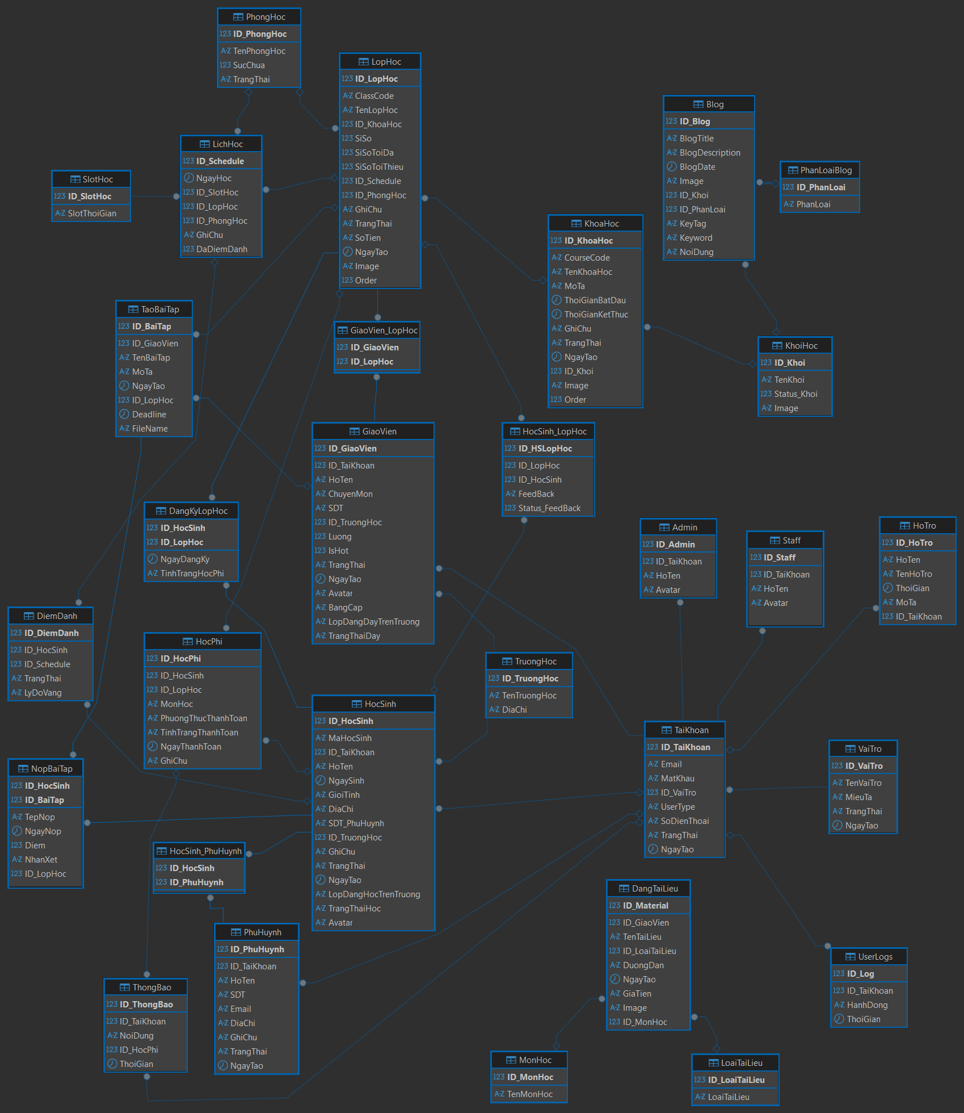

### 3.2.2 Entity Description

| **#** | **Entity** | **Description** |
| --- | --- | --- |
| 1 | TaiKhoan | **Description:** Account of the centre  **Primary key:** ID_TaiKhoan  **Foreign key:** ID_VaiTro |
| 2 | VaiTro | **Description:** Roles in the system (e.g., admin, teacher, student, parent, staff)  **Primary key:** ID_VaiTro |
| 3 | UserLogs | **Description:** User action logs  **Primary key:** ID_Log  **Foreign key:** ID_TaiKhoan |
| 4 | HoTro | **Description:** Support requests from users  **Primary key:** ID_HoTro **Foreign key:** ID_TaiKhoan |
| 5 | Admin | **Description:** Administrator information of the system  **Primary key:** ID_Admin **Foreign key:** ID_TaiKhoan |
| 6 | Staff | **Description:** Staff (employees, non-teachers)  **Primary key:** ID_Staff **Foreign key:** ID_TaiKhoan |
| 7 | GiaoVien | **Description:** Teacher information  **Primary key:** ID_GiaoVien **Foreign keys:** ID_TaiKhoan ID_TruongHoc |
| 8 | GiaoVien_LopHoc | **Description:** Assignment of teachers to classes  **Primary key:** (ID_GiaoVien, ID_LopHoc) **Foreign keys:**ID_GiaoVien  ID_LopHoc |
| 9 | LopHoc | **Description:** Class information  **Primary key:** ID_LopHoc **Foreign keys:** ID_KhoaHoc ID_PhongHoc |
| 10 | KhoaHoc | **Description:** Course information  **Primary key:** ID_KhoaHoc **Foreign key:** ID_Khoi |
| 11 | KhoiHoc | **Description:** School levels/grades  **Primary key:** ID_Khoi |
| 12 | Blog | **Description:** Blog articles posted on the system  **Primary key:** ID_Blog **Foreign keys:** ID_Khoi → KhoiHoc ID_PhanLoai → PhanLoaiBlog |
| 13 | PhanLoaiBlog | **Description:** Blog category/classification  **Primary key:** ID_PhanLoai |
| 14 | PhongHoc | **Description:** Classroom information  **Primary key:** ID_PhongHoc |
| 15 | LichHoc | **Description:** Class schedules  **Primary key:** ID_Schedule **Foreign keys:** ID_LopHoc ID_SlotHoc ID_PhongHoc |
| 16 | DiemDanh | **Description:** Attendance records of students  **Primary key:** ID_DiemDanh **Foreign keys:** ID_HocSinh ID_Schedule |
| 17 | SlotHoc | **Description:** Time slots for scheduling classes  **Primary key:** ID_SlotHoc |
| 18 | TaoBaiTap | **Description:** Teacher-created assignments  **Primary key:** ID_BaiTap **Foreign keys:** ID_GiaoVien ID_LopHoc |
| 19 | NopBaiTap | **Description:** Assignment submissions by students  **Primary key:** (ID_HocSinh, ID_BaiTap) **Foreign keys:** ID_HocSinh ID_BaiTap |
| 20 | HocSinh | **Description:** Student information  **Primary key:** ID_HocSinh **Foreign keys:** ID_TaiKhoan ID_TruongHoc |
| 21 | HocSinh_LopHoc | **Description:** Feedback and status for students in classes  **Primary key:** ID_HSLopHoc **Foreign keys:** ID_LopHoc ID_HocSinh |
| 22 | DangKyLopHoc | **Description:** Student registration for classes  **Primary key:** (ID_HocSinh, ID_LopHoc) **Foreign keys:** ID_HocSinh ID_LopHoc |
| 23 | HocPhi | **Description:** Tuition payment records  **Primary key:** ID_HocPhi **Foreign keys:** ID_HocSinh  ID_LopHoc |
| 24 | TruongHoc | **Description:** School information  **Primary key:** ID_TruongHoc |
| 25 | HocSinh_PhuHuynh | **Description:** Relationship between students and parents  **Primary key:** (ID_HocSinh, ID_PhuHuynh) **Foreign keys:** ID_HocSinh ID_PhuHuynh |
| 26 | PhuHuynh | **Description:** Parent/guardian information  **Primary key:** ID_PhuHuynh **Foreign key:** ID_TaiKhoan |
| 27 | ThongBao | **Description:** Notifications for users  **Primary key:** ID_ThongBao  **Foreign keys:** ID_TaiKhoan → TaiKhoan ID_HocPhi → HocPhi |
| 28 | DangTaiLieu | **Description:** Materials uploaded by teachers  **Primary key:** ID_Material  **Foreign keys:** ID_GiaoVien ID_LoaiTaiLieu ID_MonHoc |
| 29 | MonHoc | **Description:** Subject information  **Primary key:** ID_MonHoc |
| 30 | LoaiTaiLieu | **Description:** Document types  **Primary key:** ID_LoaiTaiLieu |

## 3.3.1 Home Page

### 1.1.1 Home Page 1.1

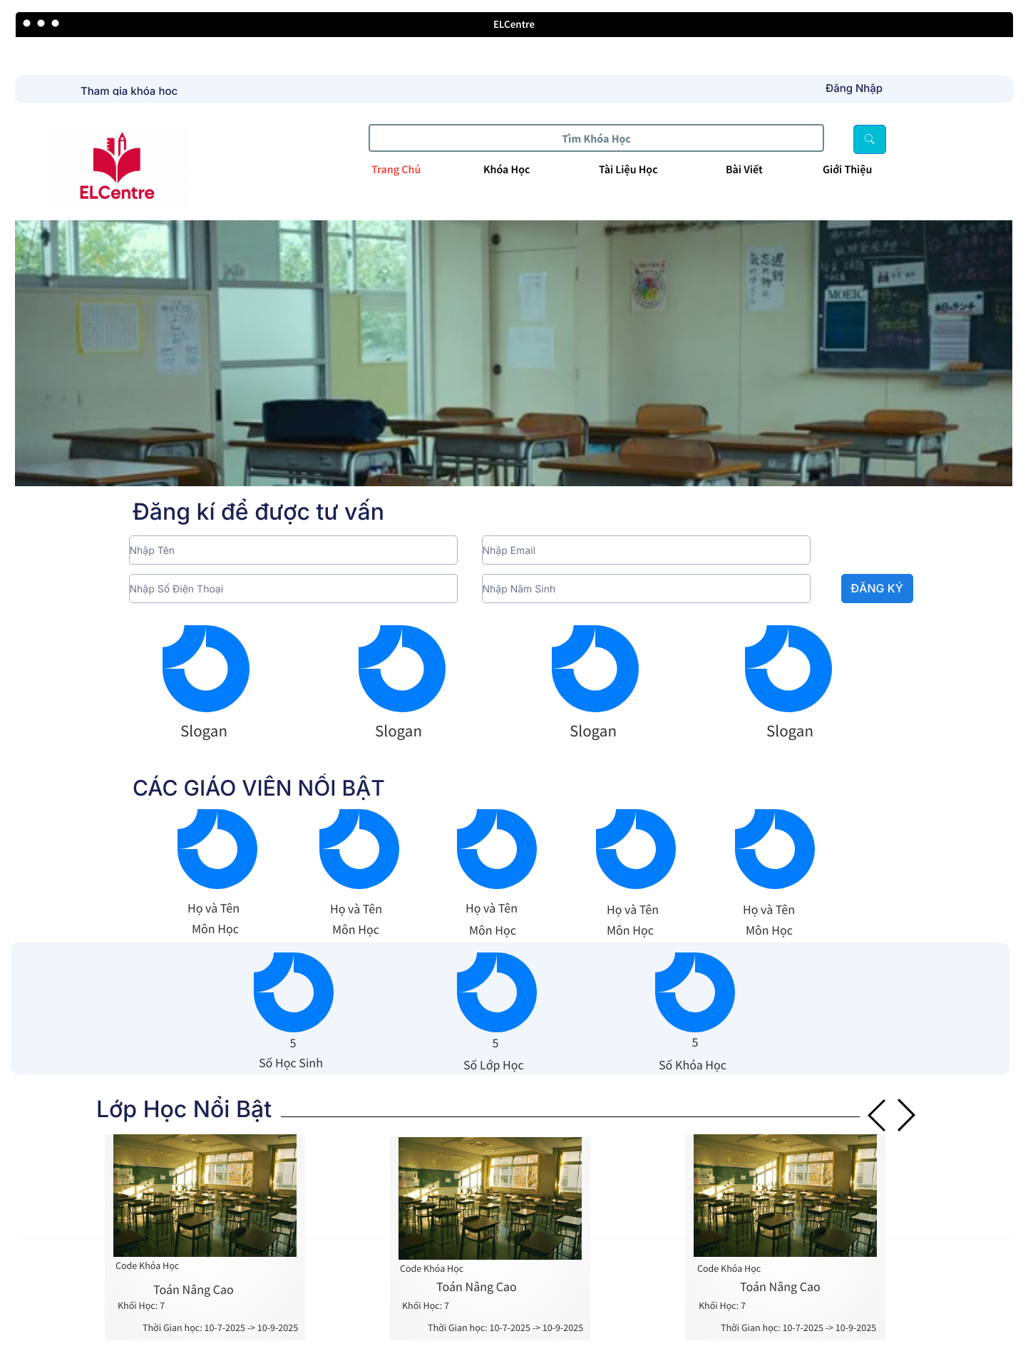

| **Field Name** | **Description** |
| --- | --- |
| Trang Chủ and Logo | Click to redirect to Home page |
| ***Login and Enroll*** | |
| Đăng Nhập and Tham Gia Khóa học | Click to redirect to Login page |
| Search Bar and icon Search | Click to search for specific courses based on entered keywords |
| ***Navigation bar*** | |
| Khóa Học | Click to redirect to Course Page to view Courses |
| Tài Liệu Học | Click to redirect to Learning Materials to view Learning Materials |
| Bài Viết | Click to redirect to Post to view Post |
| Giới Thiệu | Click to redirect to Information about Centre to view Information about Centre |
| Slider | Click to button on slider to redirect to backlink that is added by admin in database |
| Enter Name, Email, Phone Number and BirthDate for Register | Fill Name, Email, PhoneNumber and BirthDate for Registering Consultant from Centre |
| **Slogan of Centre** | |
| Slogan | Provide Slogan of Centre and Commitment |
| ***Centre’s Specialised Teachers*** | |
| Avatar | Provide Avatar and Name of Teacher |
| Môn Học | Provide Subject that Teacher takes charge of |
| **Centre’s Achievements** | |
| Achievements | Show number of students, number of active courses and available courses of Centre |
| ***Featured Class*** | |
| Class Avatar | Provide Real Class Image and backlink to register class |
| Class Name | Provide Class Name to Select the class you want to enroll in: Basic or Advanced |
| Class Tuition | Provide Class Tuition for consideration |

### 1.1.2 Home Page 1.2

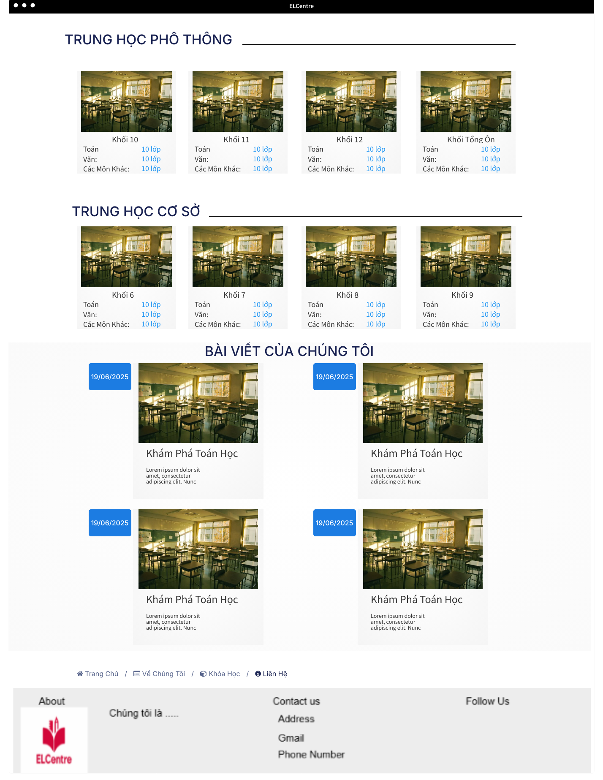

| **Field Name** | **Description** |
| --- | --- |
| ***High-school Course Category*** | |
| Course Avatar | To Show The Grade and Course’s Subject |
| Grade Name | Show the course for what grade and backlink to that grade |
| Subject Name | Show the course’s subject for user choose to link to the available course |
| ***Secondary-school Course Category*** | |
| Course Avatar | To Show The Grade and Course’s Subject |
| Grade Name | Show the course for what grade and backlink to that grade |
| Subject Name | Show the course’s subject for user choose to link to the available course |
| ***Blog Field*** | |
| Blog Name | Provide Blogname and backlink to the blog page |
| Blog Description | Provide Blog Description |
| ***Footer*** | |
| Social Media and Contact to Centre | Provide Field for customer to contact with centre |

### 1.1.3 Home Page Course

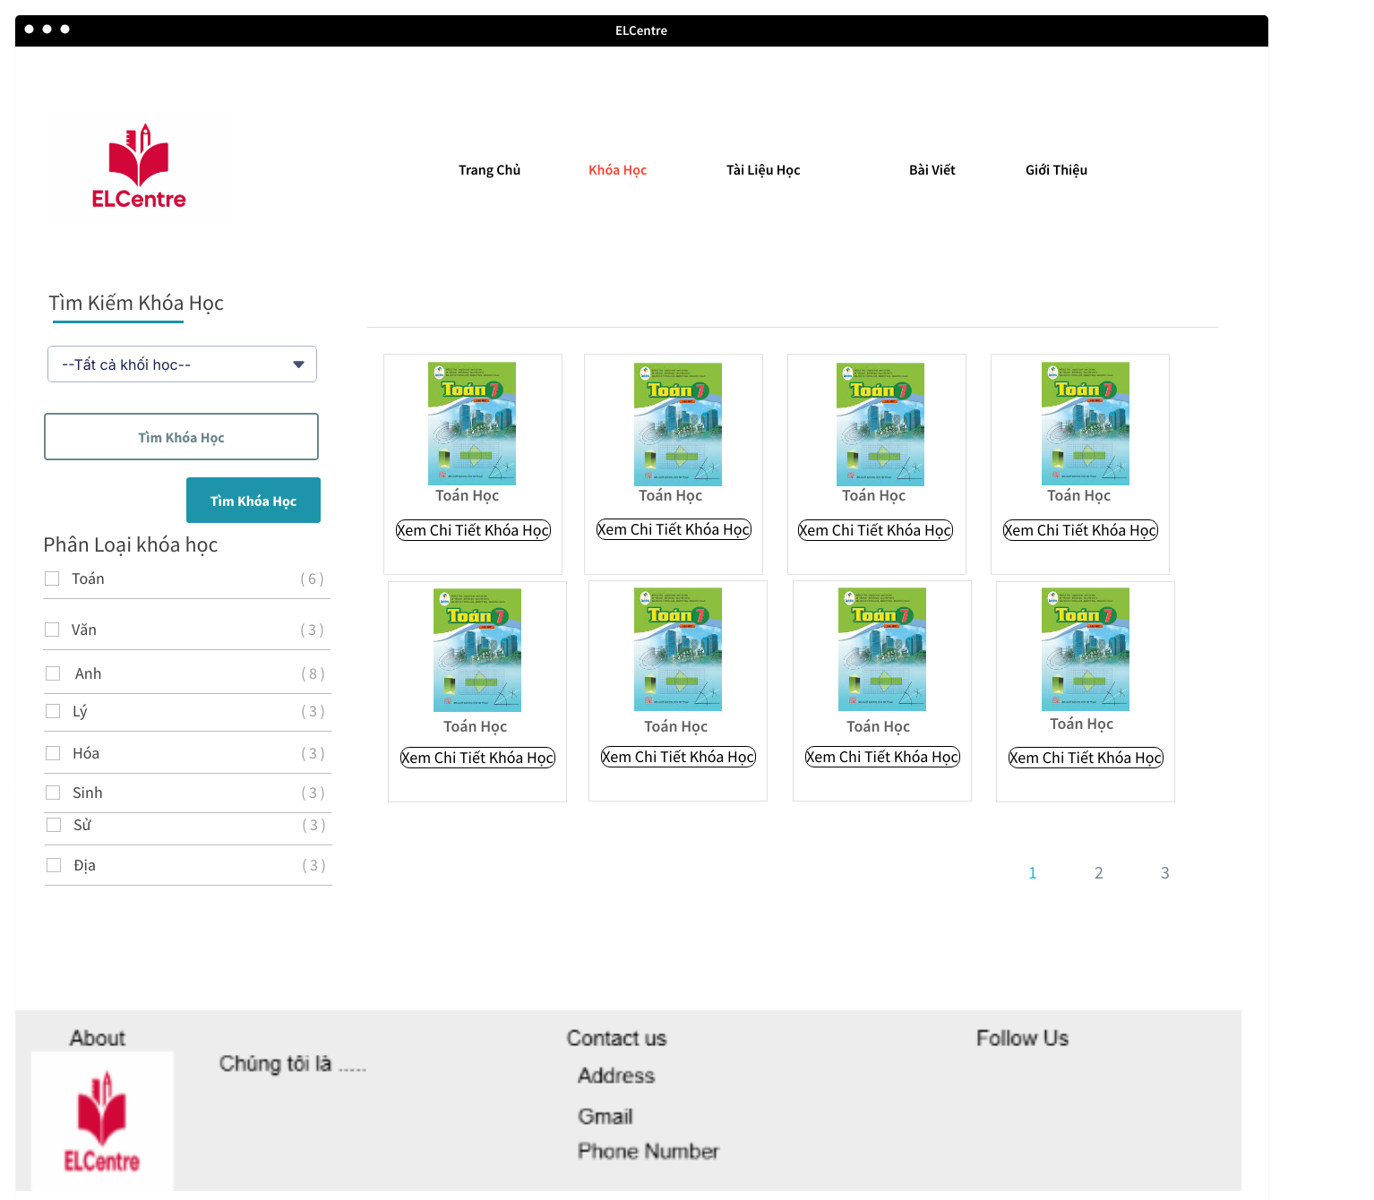

| **Field Name** | **Description** |
| --- | --- |
| ***Find Courses*** | |
| Course Field | Fill the course’s field to find wanted course |
| Find Course Button | Click button to find course |
| ***Filter Courses*** | |
| Course Name | Show all Courses Available |
| Tick Box | For user to filter wanted courses |
| ***List Courses*** | |
| Course Name | Provide Course’s Name |
| View Details | Provide Backlink to the details of course |
| Pagination | Pagination for looking easier |

### 1.1.4 Home Page Materials

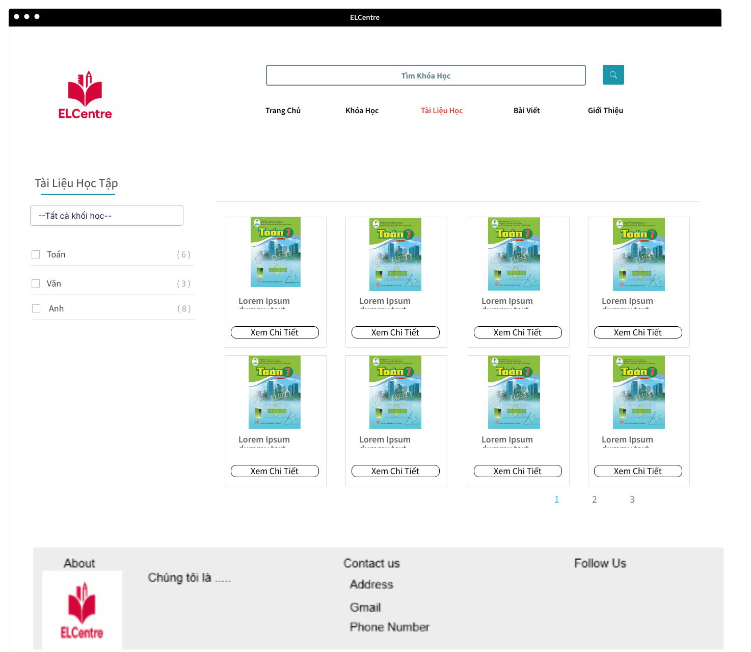

| **Field Name** | **Description** |
| --- | --- |
| ***Learning Materials*** | |
| Subject’s Materials | Provide Subject’s Name |
| Tick Box | For user to filter wanted courses |
| ***List Materials*** | |
| Subject Name | Provide Subject’s Name |
| View Details | Provide Backlink to the details of Materials |
| Material’s Type | Provide Type for Material |

### 1.1.5 Home Page Post

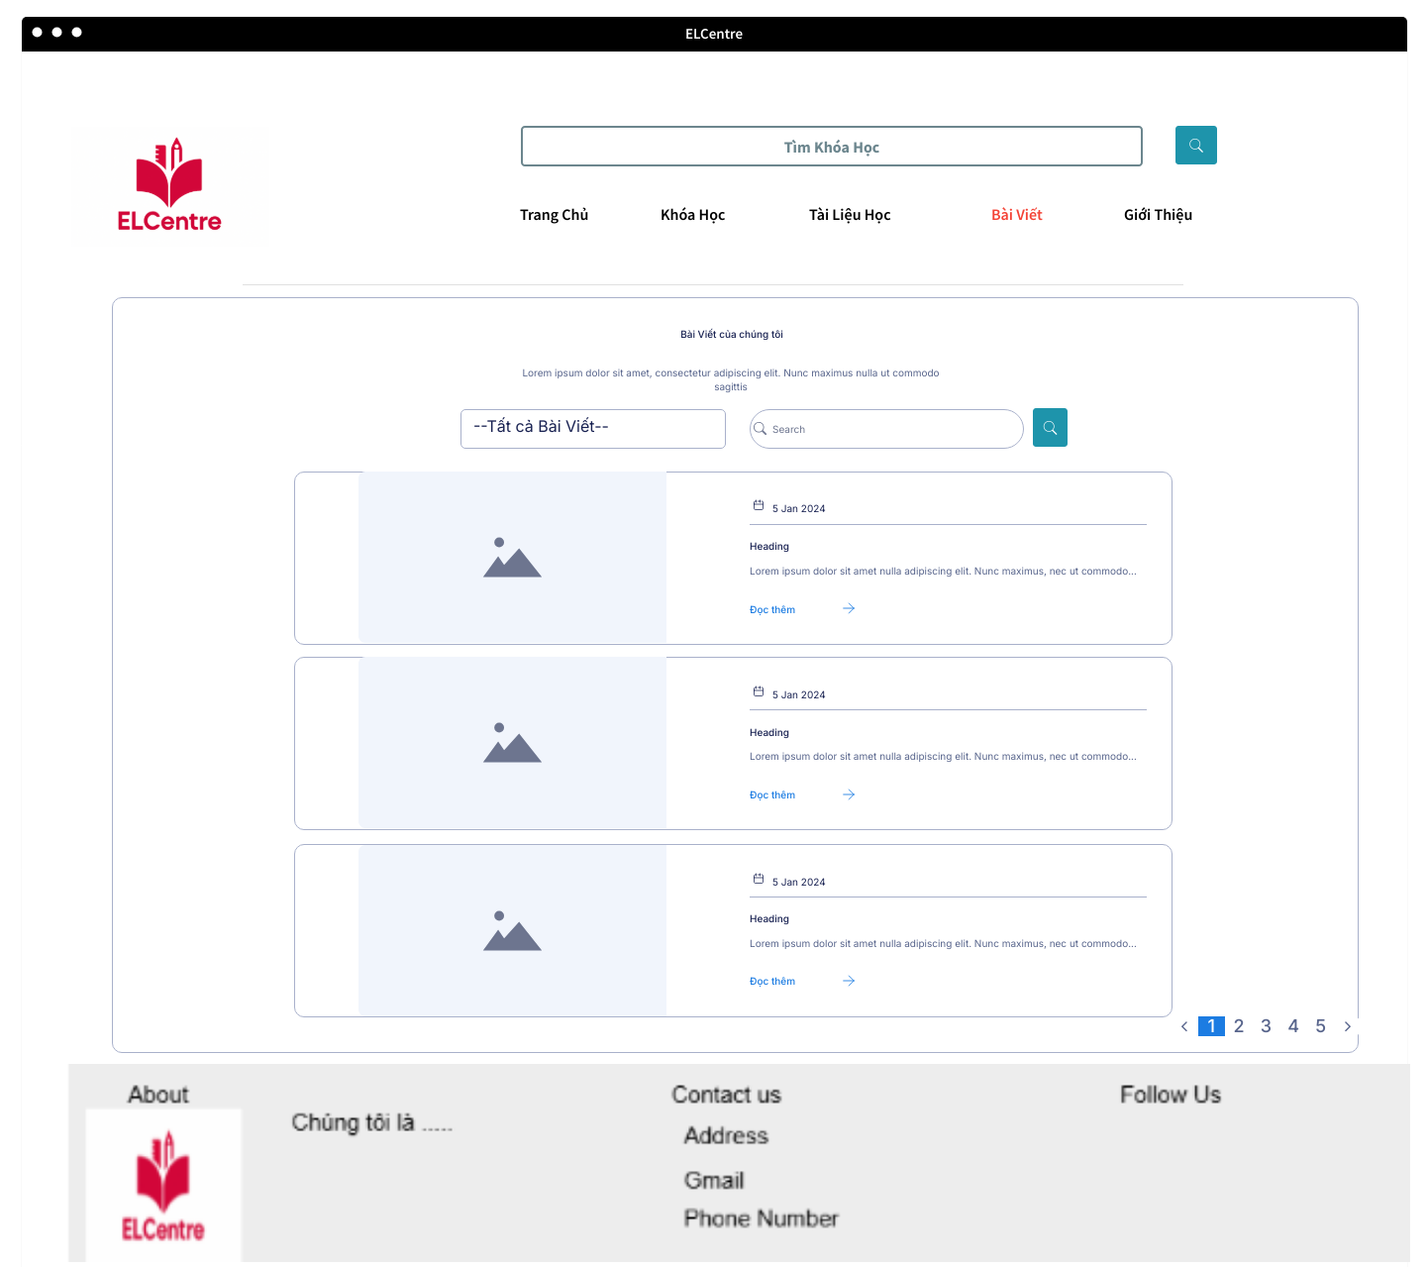

| **Field Name** | **Description** |
| --- | --- |
| ***Blog’s Search Bar*** | |
| Blog’s Field | Fill the blog’s field to find wanted post |
| Search Button | Click button to find post |
| ***List Blogs*** | |
| Blog’s Name | Provide Blog’s Name |
| Content | Provide Content of the post |
| Đọc Thêm | Provide Backlink to the details of post |
| Pagination | Pagination for looking easier |

### 1.1.6 Home Page Introduction and Contact

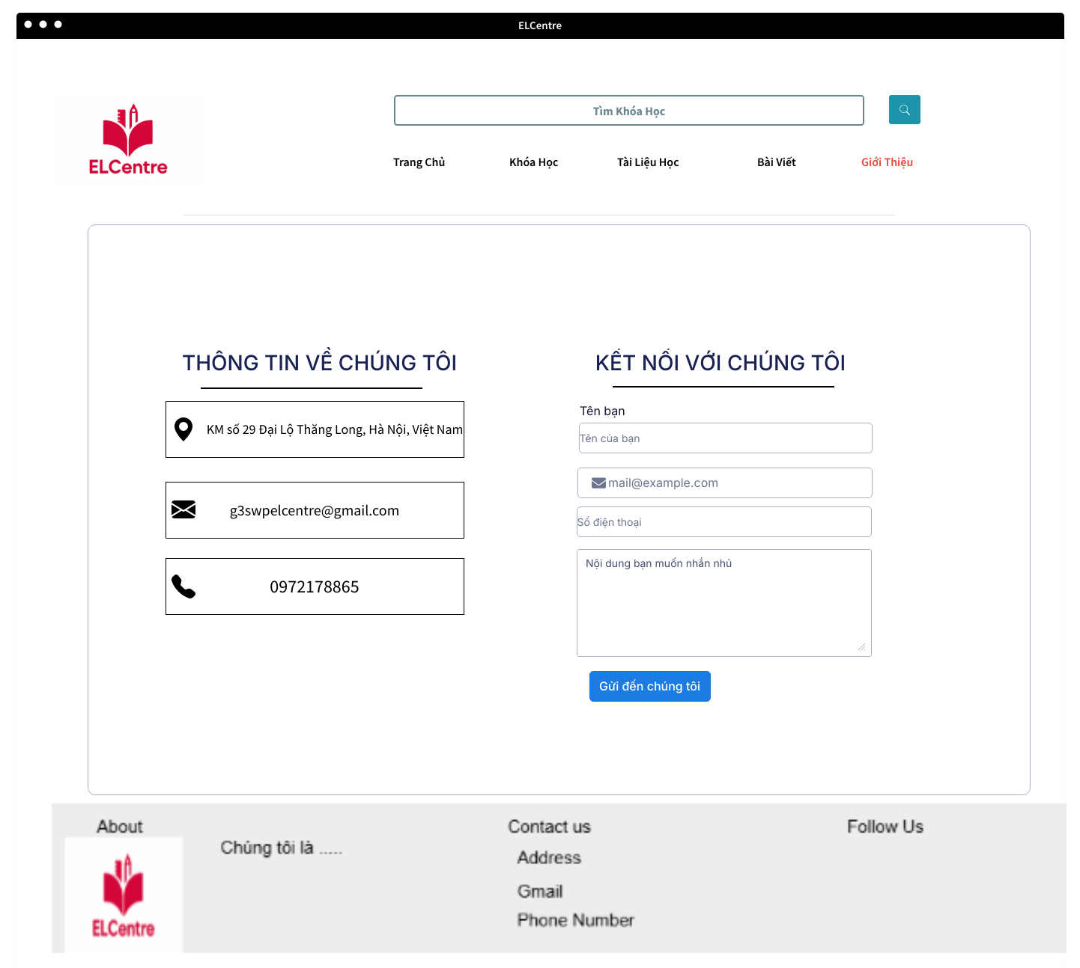

| **Field Name** | **Description** |
| --- | --- |
| ***Centre’s Information*** | |
| Address Field | Provide Centre’s Address |
| Gmail Field | Provide Centre’s Gmail |
| Hotline | Provide Centre’s Hotline |
| ***Contact with Centre*** | |
| Name Field | Fill the Name to contact with centre |
| Mail Field | Fill the Mail to contact with centre |
| Phone Number Field | Fill the Phone Number to contact with centre |
| Message | Fill the Message to contact with centre |
| Send Button | Send content to the centre |

## 3.3.2. System Administration

### *2.2.1Admin Dashboard*

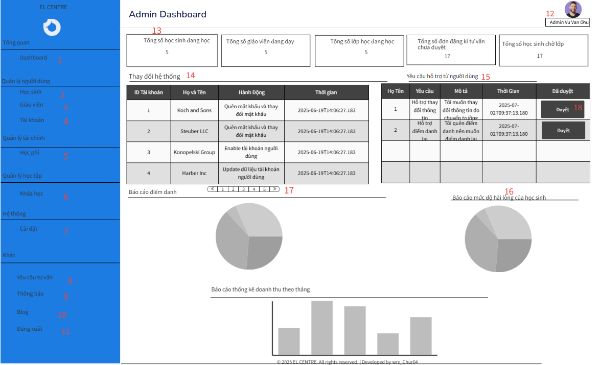

This screen allows the Administrator to:

* View total student are learning that have class at the center
* View total number of teachers teaching that have class at the center
* View total number of classes currently available at the center
* View total consultation from user not approved yet
* View total student are waiting for class to learn at the center
* View recent user activity on the system like someone changing password , update information , ….
* View the require support from user : User want to support by admin with some problem about system
* View attendance today chart : Chart showing attendance of student today
* View student satisfied chart : Chart showing students satisfied or not after done in class
* View revenue chart by month : Chart is showing revenue of center by month

**Field Description**

| **Field Name** | **Description** |
| --- | --- |
| (1) | Click to back the admin Dashboard |
| (2) | Click to go to the student management screen |
| (3) | Click to go to the teacher management screen |
| (4) | Click to go to the user's account management screen |
| (5) | Click to go to the tuition management screen |
| (6) | Click to go to the course management screen |
| (7) | Click to go to the setting management screen |
| (8) | Click to go to the approve consultation screen |
| (9) | Click to go to the notifications management screen |
| (10) | Click to go to the blog management screen |
| (11) | Click to log out the account , back to the home page screen |
| (12) | Click and choose to update information of account or change password of account |
| (13) | View the total number of students currently attending classes at the center (students who have a class and are actively studying)  View the total number of teachers currently teaching at the center (teachers who have a class to teach and are actively teaching)  View the total number of classes currently active at the center  View the total number of consultation requests that have not been approved  View the total number of students waiting to be assigned to a class at the center |
| (14) | View system requests made today, such as password changes, account information updates, etc., sorted by most recent and with the ability to filter by date |
| (15) | View user support requests over time that are still pending approval, such as class transfer requests, attendance corrections, etc. |
| (16) | Chart showing student satisfaction after each class session (real data from the database) |
| (17) | Pagination for the system request table |

#### 2.2.2 Manage Account Of User

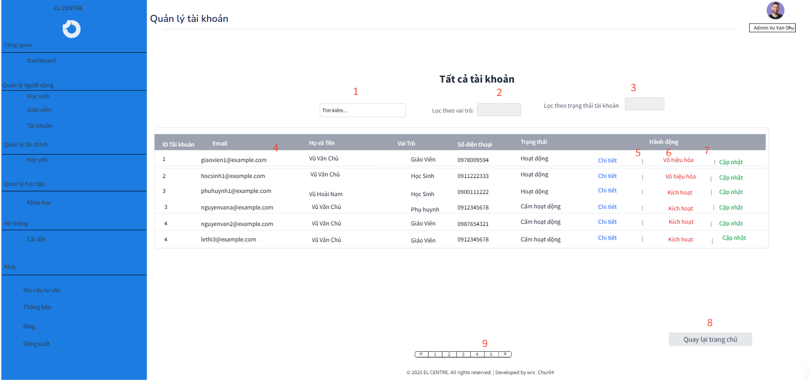

This screen allows the Administrator to:

* View List Of Account:View email , usertype , status , number of account user

On the screen, s/he can also

* Click to go to the admin dashboard screen
* Click to search the account of user
* Filter user by role : Teacher , Student , Parent Of Student
* Filter by Status : Active , Inactive
* View Details Account : Address , Phone Number , School , Subject , ……
* Disable account if account is not use
* Update information of this account
* Click to go to the other page of account user
* Click to change admin account information or change password

**Field Description**

| **Field Name** | **Description** |
| --- | --- |
| (1) | Click to search the account of user by email ,phone number , name |
| (2) | Select to filter by role of account like Student , Parent Of Student , Teacher |
| (3) | Select to filter account by status like active or inactive |
| (4) | All information of account |
| (5) | Click to go to the screen have specific information of user |
| (6) | Click to disable or enable account of user |
| (7) | Click to go the the update information account of user screen |
| (8) | Click to back the admin DashBoard |
| (9) | Click to go to other pages of account user |

#### 2.2.3 Manage Teacher

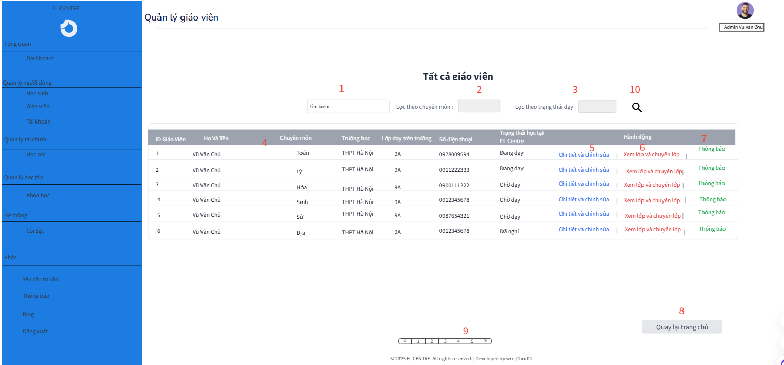

This screen allows the Administrator to:

* View list of teachers : On screen admin can view Full name , phone number , status of teacher in center like are working or wait to leave work, course , class of teacher in school and school where teachers are working .

On the screen, s/he can also

* Click to go to the admin dashboard screen
* Click to go to another pages
* Click to view details information of teacher
* Click to view all of class of this teacher and view all students in this class
* Click to update information of this teacher
* Enter something to search teacher
* Select to filter teacher by course of teacher
* Click to choose update admin information or change password of admin account

**Field Description**

| **Field Name** | **Description** |
| --- | --- |
| (1) | Enter something to search teacher like name , phone number |
| (2) | Filter teachers by course name like Math , .. |
| (3) | Filter teachers by their teaching status at the center, such as currently teaching, resigned, or waiting for a class. |
| (4) | View information of list teacher |
| (5) | Click to view , update details information of this teacher like school , class in school , top hot , phone number ,.. |
| (6) | Click to view all class of this teacher , change class for teacher and view all student and some student information of this class |
| (7) | Click to send notification for this teacher |
| (8) | Click to back the admin dashboard |
| (9) | Click to go to the another pages |
| (10) | Click to active search , filter |

#### 2.2.4 Manage Student

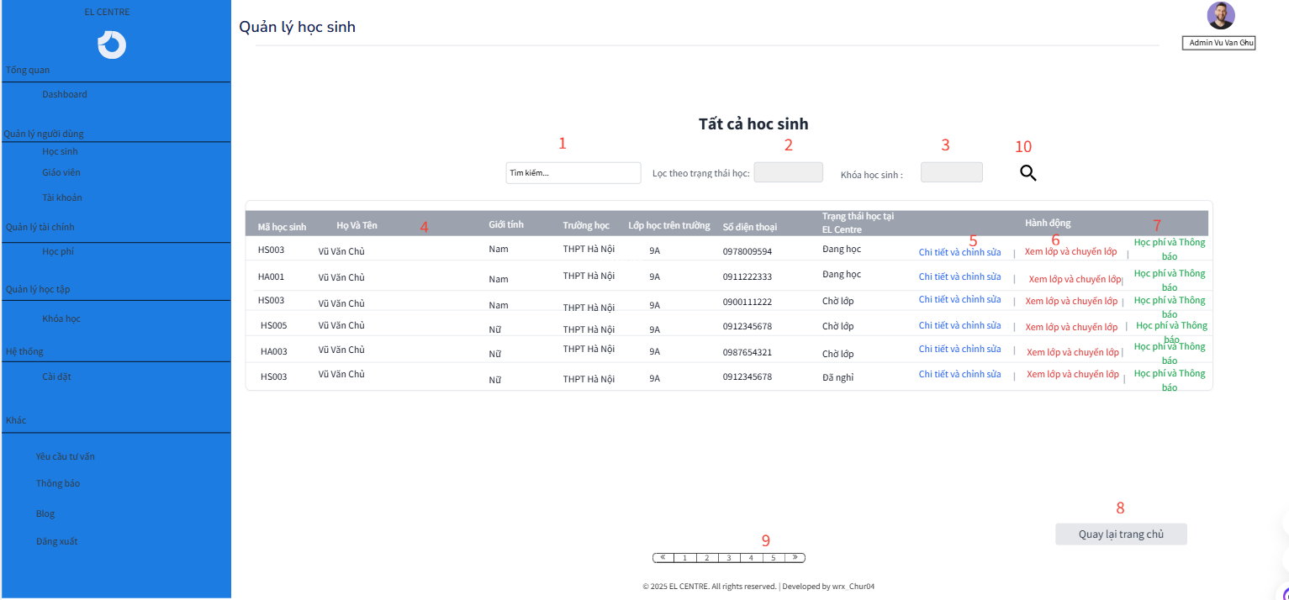

This screen allows the Administrator to:

* View students list : On this screen , admin can view full name, student code , phone number , school and class in school , gender , status in center of student .

On the screen, s/he can also

* Click to go to the admin dashboard screen
* Enter to search student
* Click to go to another pages
* Filter user by status of student in center like waiting to class to learn , are learning , or leave learn
* View student details : Click to view student details information like address , ...
* View student class in center and change class of student in center
* Click to change information of this student
* View status tuition and send notification for this student
* Click to choose update admin information or change password of admin account

**Field Description**

| **Field Name** | **Description** |
| --- | --- |
| (1) | Enter something to search student like name , phone number , student code |
| (2) | Filter students by enrollment batch (based on the student code). |
| (3) | Filter students by their study status at the center, such as currently studying, withdrawn, or waiting for a class. |
| (4) | View information of list student |
| (5) | Click to view , update details information of this student like school , class in school , phone number ,.. |
| (6) | Click to view all class of this student , change class for student |
| (7) | Click to send notification for this student and view status tuition |
| (8) | Click to back the admin dashboard |
| (9) | Click to go to the another pages |
| (10) | Click to active search , filter |

#### 2.2.5 Manage Course screen

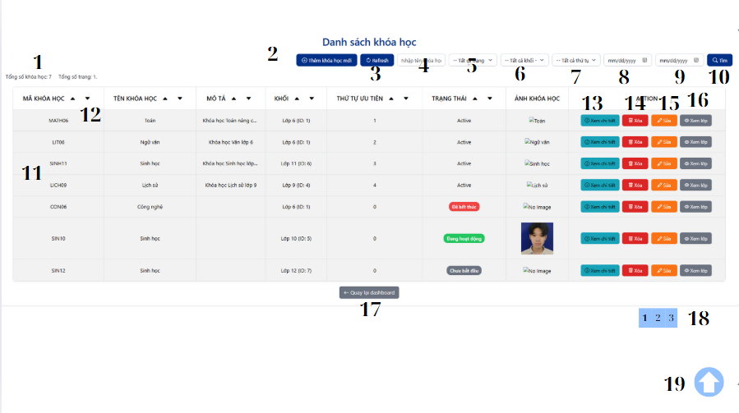

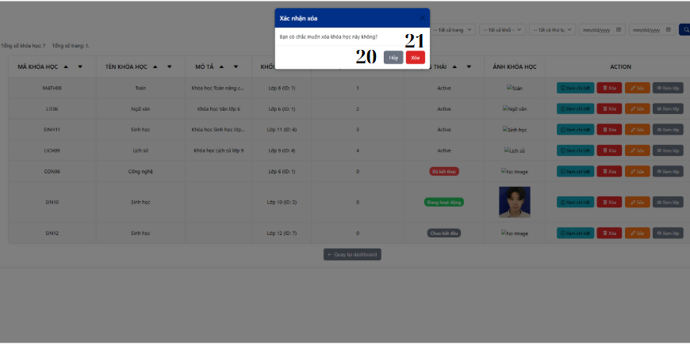

| **Field Name** | **Description** |
| --- | --- |
| (1) | Display total course and total page |
| (2) | Click to go to addCourse.jsp page |
| (3) | Click to refresh manageCourse.jsp |
| (4) | Click to input name of course |
| (5) | Click to select status of course |
| (6) | Click to select class of course |
| (7) | Click to select priority of course |
| (8) | Click to select day start of course |
| (9) | Click to select day end of course |
| (10) | Click to find course |
| (11) | Display course list |
| (12) | Click to sort by attribute |
| (13) | Click to view more information of course |
| (14) | Click to delete course |
| (15) | Click to go to upadateCourse.jsp page |
| (16) | Click to go to manageClass.jsp page |
| (17) | Click to go to adminDashBoard |
| (18) | Click to choose page (pagination) |
| (19) | Click to return to top |
| (20) | Click to cancel key deletion |
| (21) | Click to confirm course deletion |

#### 2.2.6 AddCourse screen

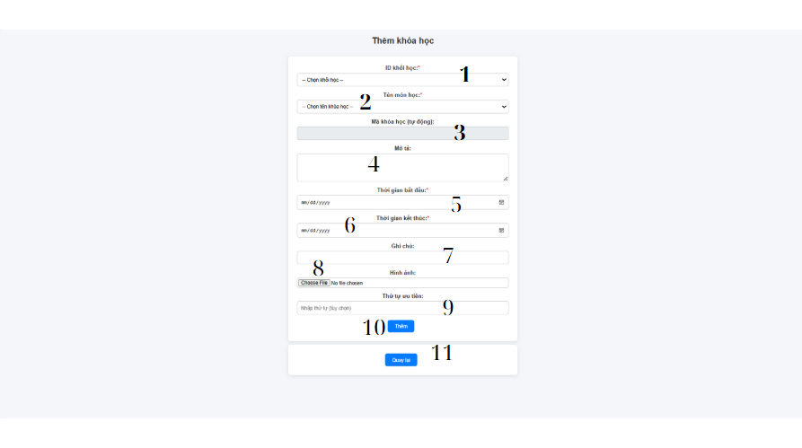

| **Field Name** | **Description** |
| --- | --- |
| (1) | Click to select ID_KhoiHoc |
| (2) | Click to select name of course |
| (3) | Course code is automatically generated |
| (4) | Click to input description of class |
| (5) | Click to select time begin |
| (6) | Click to select time end |
| (7) | Click to input note |
| (8) | Click to input image |
| (9) | Click to input priority of course |
| (10) | Click to add course |
| (11) | Click to return manageCourse.jsp page |

#### 

#### 2.2.7 UpdateCourse screen

| **Field Name** | **Description** |
| --- | --- |
| (1) | Click to change description of class |
| (2) | Click to change time begin |
| (3) | Click to change time end |
| (4) | Click to change note |
| (5) | Click to change status of course |
| (6) | Click to change image of course |
| (7) | Click to change priority of course |
| (8) | Click to updateCourse |
| (9) | Click to return manageCourse.jsp page |

#### 2.2.8 ManageClasses

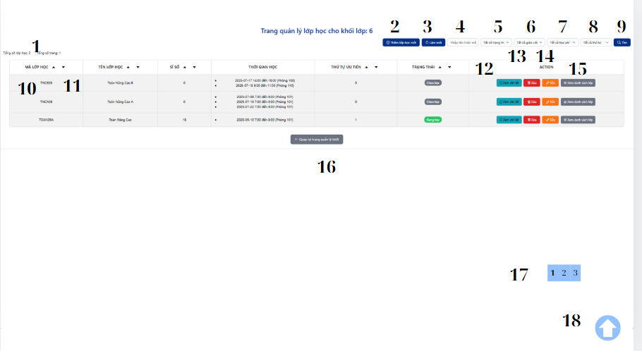

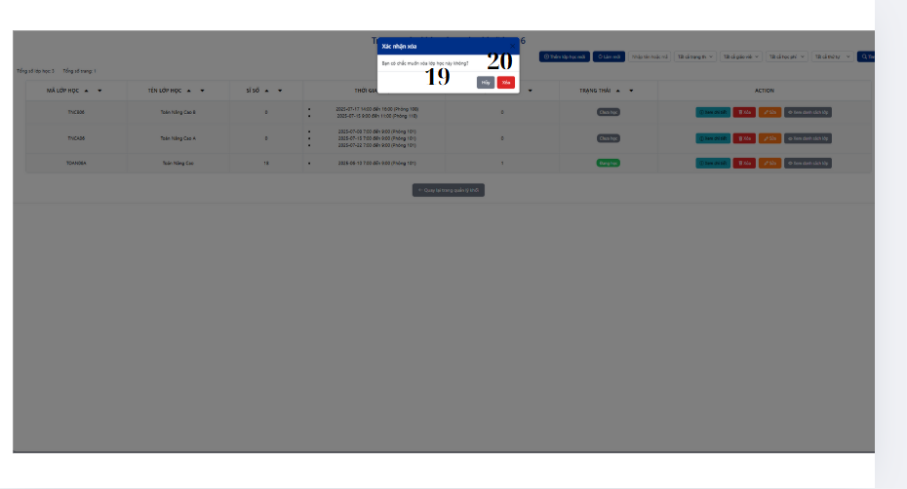

| **Field Name** | **Description** |
| --- | --- |
| (1) | Display total class and total page |
| (2) | Click to go to addClass.jsp page |
| (3) | Click to refresh manageClass.jsp |
| (4) | Click to input name of class |
| (5) | Click to select status of class |
| (6) | Click to select name of teacher |
| (7) | Click to select fee of class |
| (8) | Click to select priority of class |
| (9) | Click to find class |
| (10) | Display class list |
| (11) | Click to sort by attribute |
| (12) | Click to view more information of class |
| (13) | Click to delete class |
| (14) | Click to go to updateClass.jsp page |
| (15) | Click to go to manageClassDetail.jsp page |
| (16) | Click to go to adminDashBoard |
| (17) | Click to choose page (pagination) |
| (18) | Click to return to top |
| (19) | Click to cancel key deletion |
| (20) | Click to confirm course deletion |

#### 2.2.9 Add Class Screen

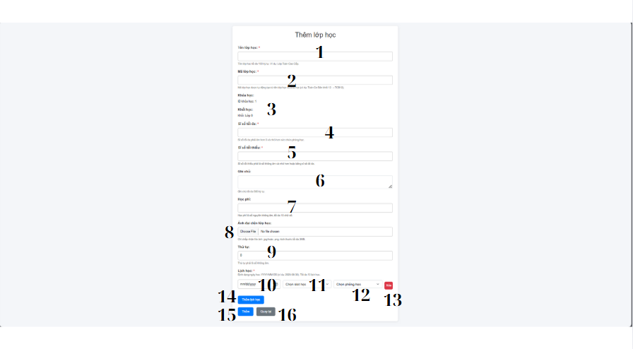

| **Field Name** | **Description** |
| --- | --- |
| (1) | Click to input name of new class |
| (2) | Class code is automatically generated |
| (3) | Display infor ID_Course and ID_Khoi |
| (4) | Click to input max number of student in class |
| (5) | Click to input min number of student in class |
| (6) | Click to input note of class |
| (7) | Click to input fee of class |
| (8) | Click to upload picture |
| (9) | Click to select priority of class |
| (10) | Click to select day learn of class |
| (11) | Click to select SLotlearn of class |
| (12) | Click to select Room of class |
| (13) | Click to remove (day,slot,room) |
| (14) | Click to add new (day,slot,room) |
| (15) | Click to add class |
| (16) | Click to return manageClass.jsp page |

#### 2.2.10 Update Class Screen

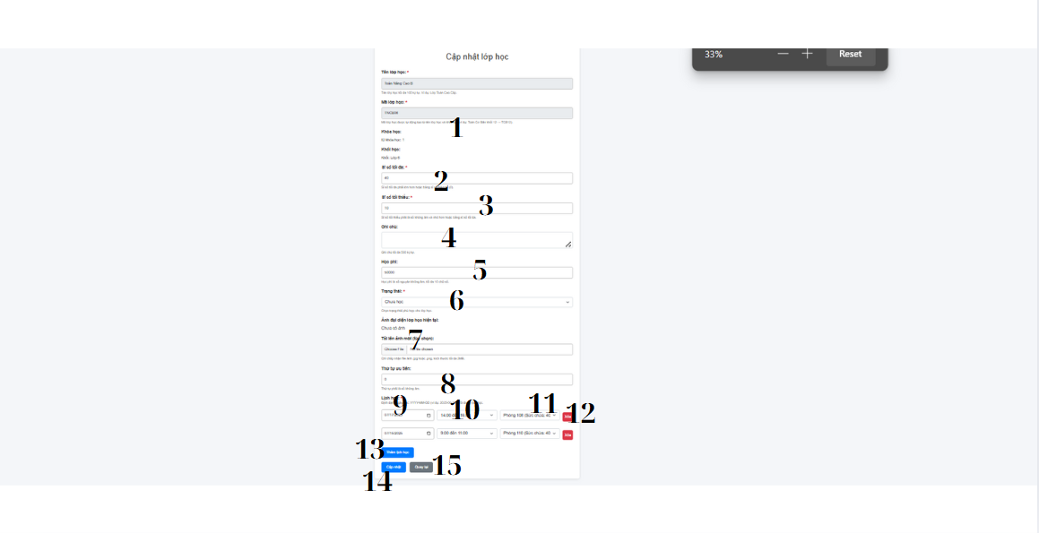

| **Field Name** | **Description** |
| --- | --- |
| (1) | Display information of class cannot update |
| (2) | Class code is automatically generated |
| (3) | Click to change max number of student in class |
| (4) | Click to change min number of student in class |
| (5) | Click to change note of class |
| (6) | Click to change fee of class |
| (7) | Click to change upload picture |
| (8) | Click to change priority of class |
| (9) | Click to change day learn of class |
| (10) | Click to change SLotlearn of class |
| (11) | Click to change Room of class |
| (12) | Click to remove (day,slot,room) |
| (13) | Click to add new (day,slot,room) |
| (14) | Click to update class |
| (15) | Click to return manageClass.jsp page |

#### 2.2.11 View Class Information

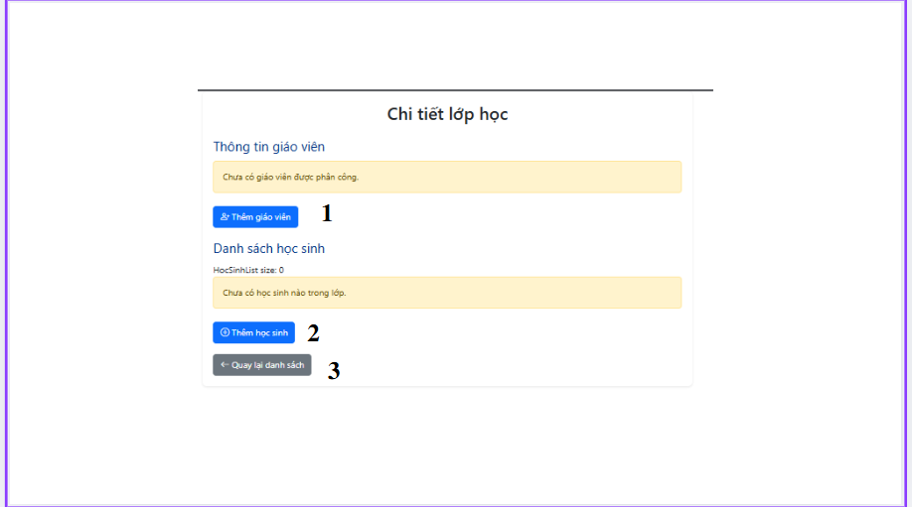

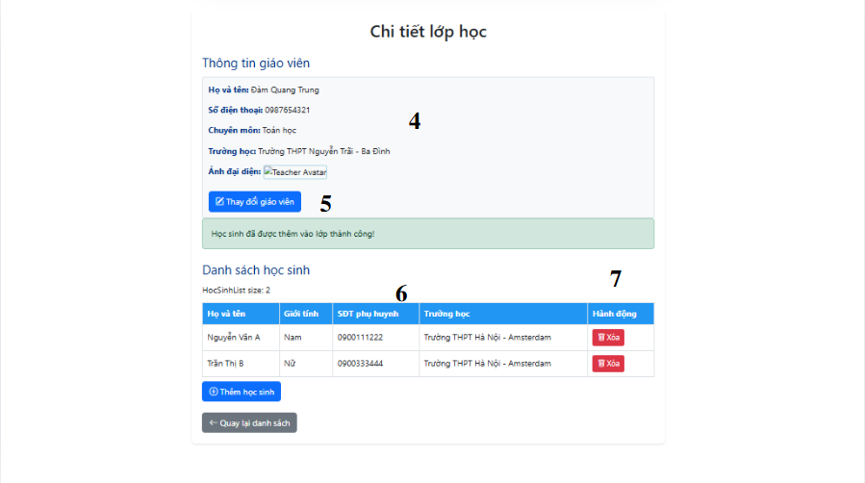

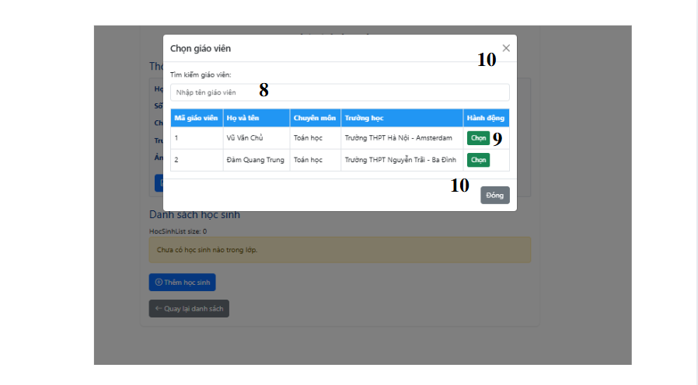

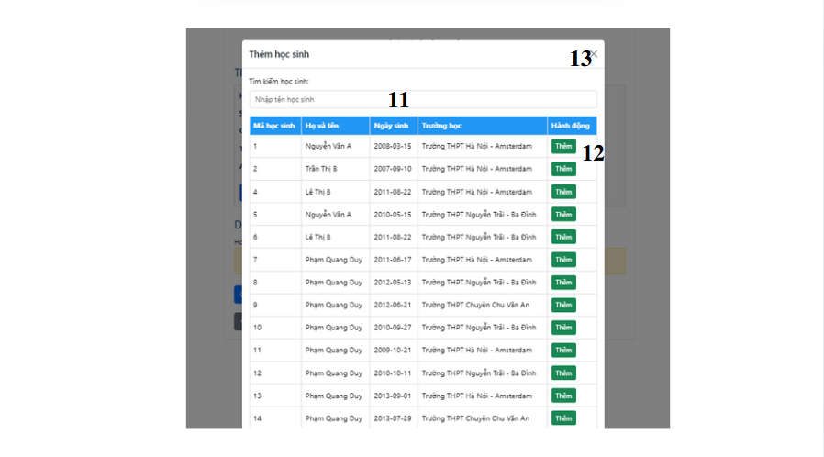

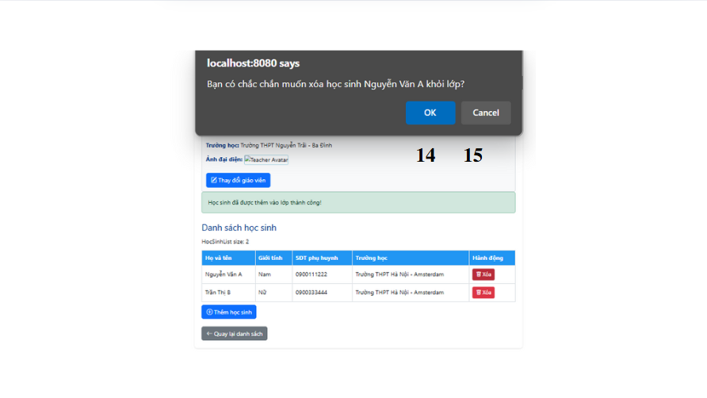

| **Field Name** | **Description** |
| --- | --- |
| (1) | Click to display table addTeacher |
| (2) | Click to display table |
| (3) | Click to back manageClass.jsp page |
| (4) | Display information of teacher |
| (5) | Click to change teacher |
| (6) | Display information of teacher |
| (7) | Click to move out |
| (8) | Click to input name of teacher |
| (9) | Click to choose student Click button to add teacher |
| (10) | Click to back viewClass.jsp |
| (11) | Click to input name of student |
| (12) | Click to add student |
| (13) | Click to back viewClass.jsp |
| (14) | Click to reject move out student |
| (15) | Click to accept move out student |

## 3.3.3. Student

#### 3.1.1 Student Dashboard

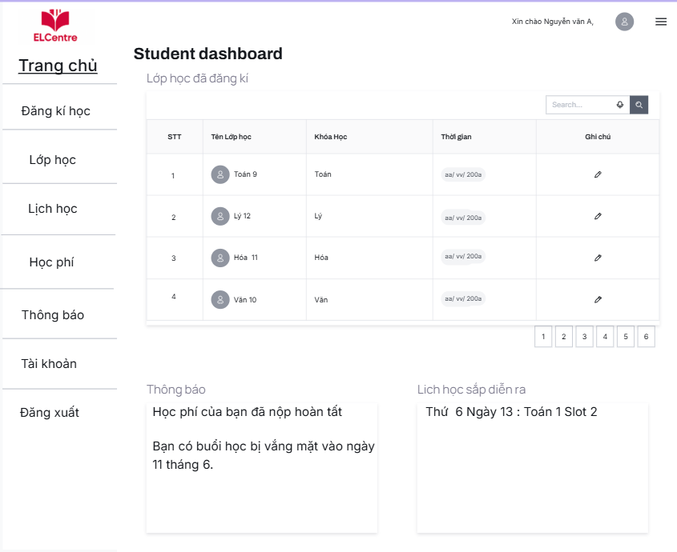

#### 3.1.2 Student enroll class

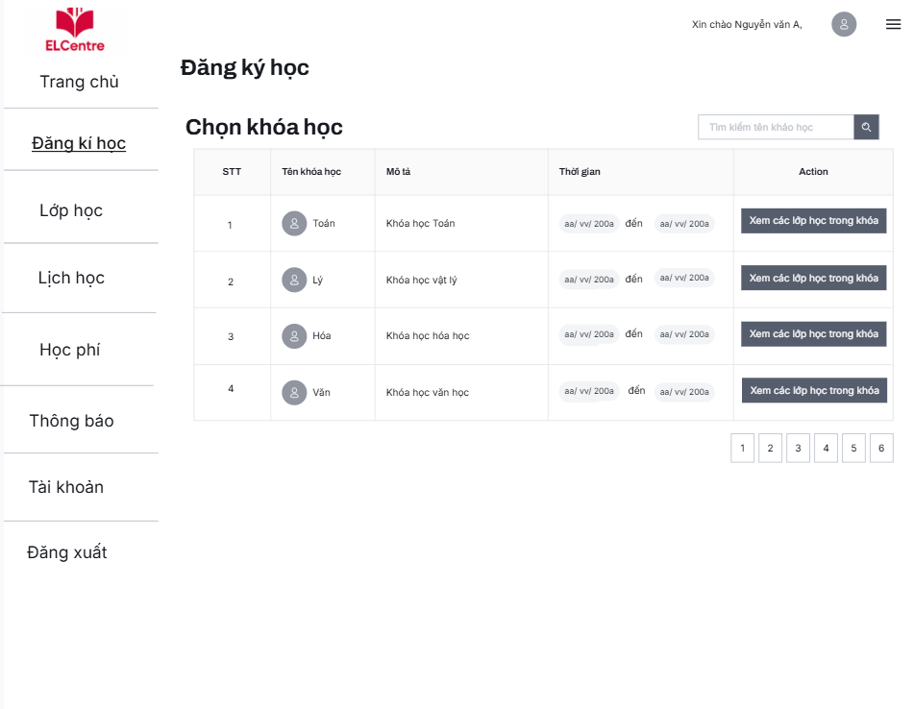

| **Field Name** | **Description** |
| --- | --- |
| (1) | Click to display table addTeacher |
| (2) | Click to display table |
| (3) | Click to back manageClass.jsp page |
| (4) | Display information of teacher |
| (5) | Click to change teacher |
| (6) | Display information of teacher |
| (7) | Click to move out |
| (8) | Click to input name of teacher |
| (9) | Click to choose student Click button to add teacher |
| (10) | Click to back viewClass.jsp |
| (11) | Click to input name of student |
| (12) | Click to add student |
| (13) | Click to back viewClass.jsp |
| (14) | Click to reject move out student |
| (15) | Click to accept move out student |

#### 3.1.2.1 Student enroll class detail

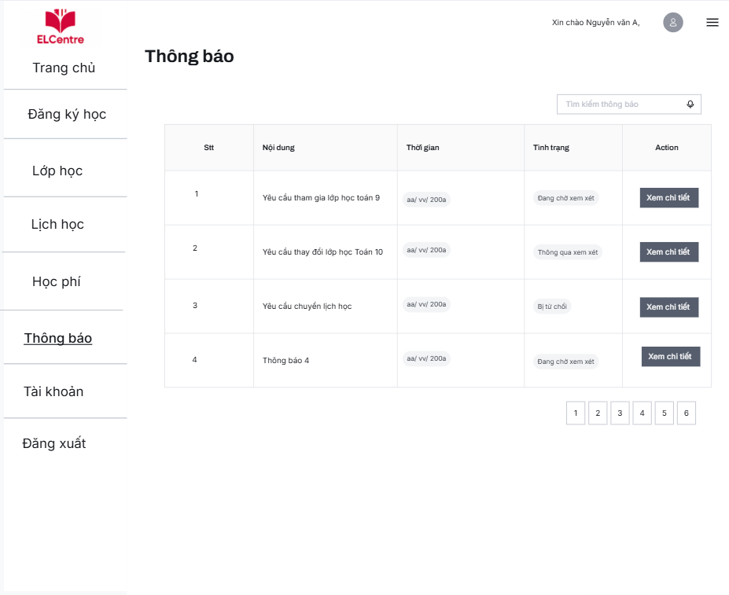

#### 3.1.3 Student Change class

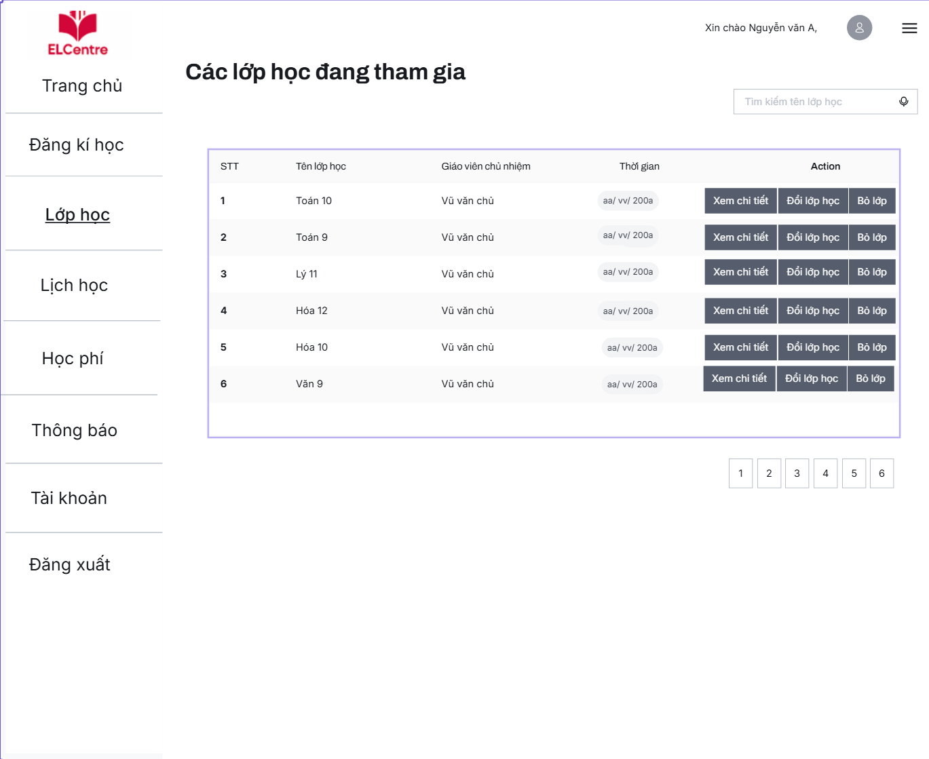

#### 

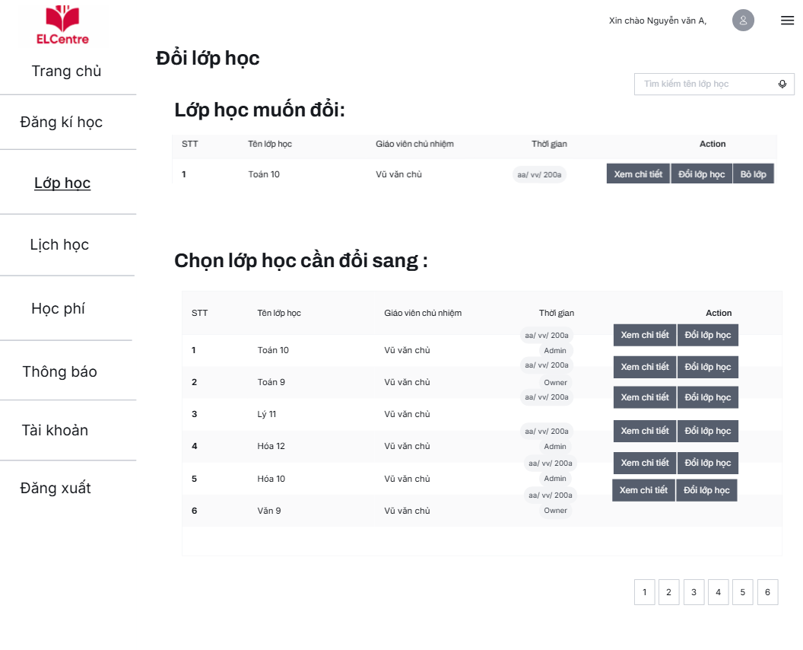

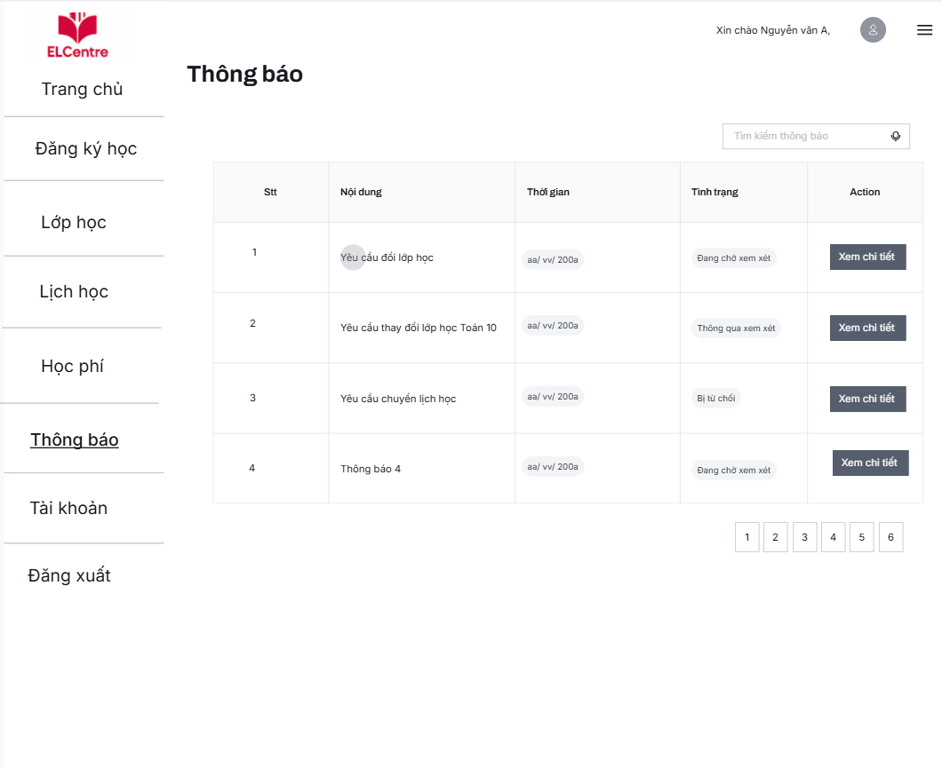

#### 

#### 

#### 

#### 

#### 3.1.4 Student view attendance and schedule

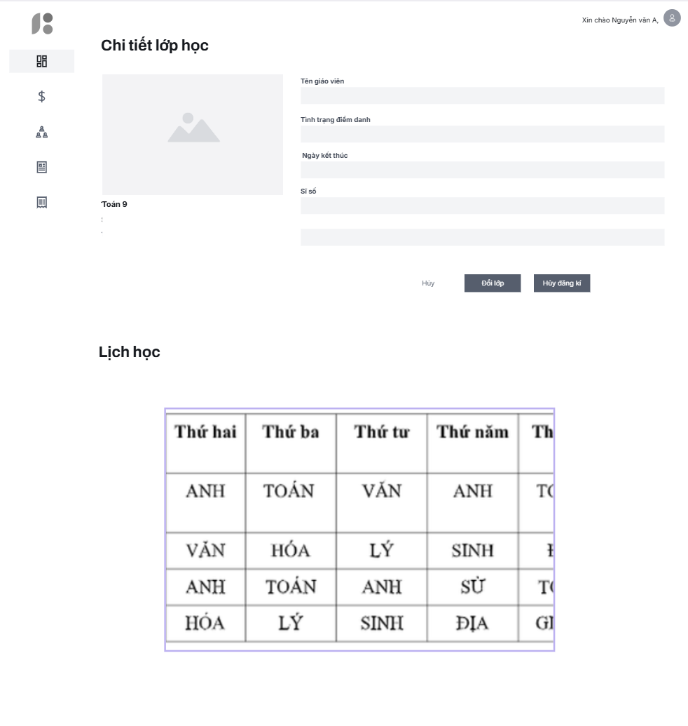

## 

## 

## 

## 

## 

## 

## 3.3.4. System Teacher

#### 4.1.1 Teacher Dashboard

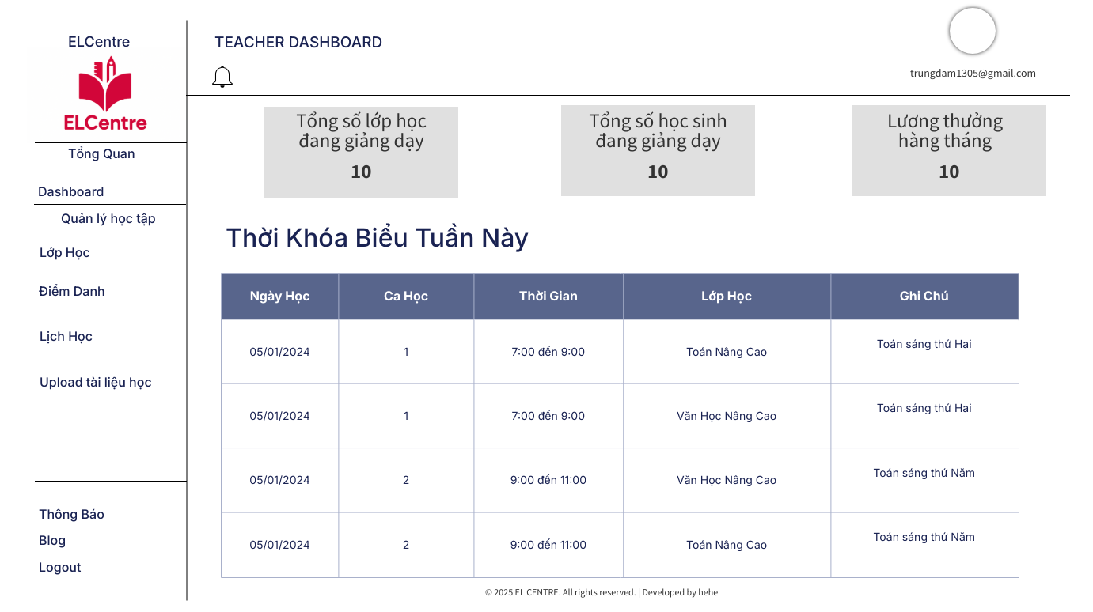

### 

| **Field Name** | **Description** |
| --- | --- |
| ***User Name*** | |
| Teacher Name | Provide Teacher’s Name |
| Avatar | Click to return to reset password |
| ***Navigation Bar*** | |
| Class Manage | Click to request to page attended classes |
| Attendance Manage | Click to request to check attendance for student |
| Schedule View | Click to view Schedule for teaching |
| Upload material | Click to upload materials for specified class |
| Student Manage | Click to view student that the teacher taught |
| Notification | Click to view Notification from the centre |

# 3.3.5. System

# *5.1.1 Login*

| **Field Name** | **Description** |
| --- | --- |
| ***Login Field*** | |
| Login Email | Enter your login account email |
| Login Password | Enter your login account password |
| Create new account | Clicks to go to new account registration page |
| Forgot password | Clicks to go to forgot password page |
| Login button | Clicks to go to home page |
| Login remember session | Allow to remember login sessions |
| ***Footer*** | |
| Login Social Media  <Comming soon> | Provide Social Account Login Features |

*5.1.2 Forgot Password*  
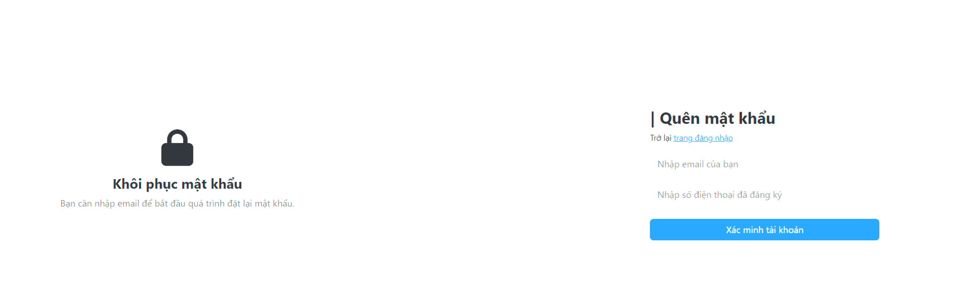

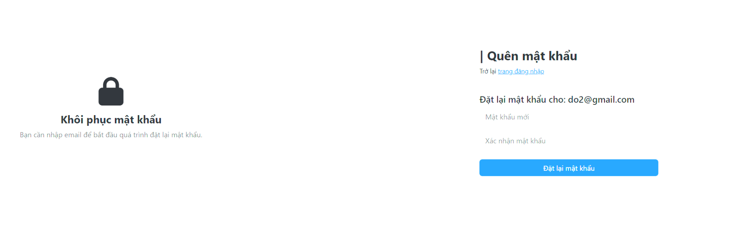

| **Field Name** | **Description** |
| --- | --- |
| ***Register Field*** | |
| Login button | Click to go to login page |
| Forgot email | Input email forgot account |
| Forgot phone | Input phone forgot account |
| Check information account | Check information account if true so come to reset password page |
| Input new password update | Input new password to reset password account |
| Confirm password | Confirm password to check duplicate |
| Reset password button | Click to update new password |

#### 5.1.3 User profile

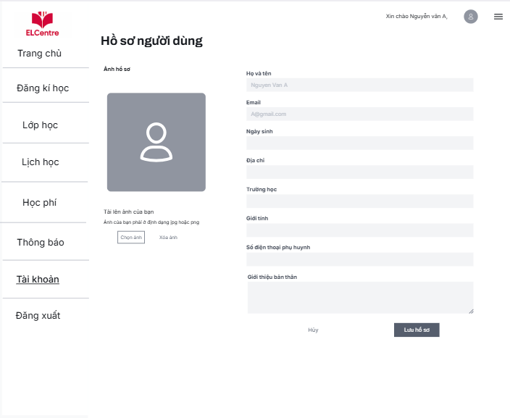

| **Field Name** | **Description** |
| --- | --- |
| (1) | Click to return to dashboard page |
| (2) | Click view menu useuser |
| (3) | Choose image to upload profile |
| (4) | Remote image profile |
| (5) | Edit full name |
| (6) | Edit email |
| (7) | Edit date of birth |
| (8) | Edit school |
| (9) | Edit sex |
| (10) | Edit parent phone |
| (11) | Edit about me |
| (12) | Save change |
| (13) | Not change |
|  |  |

## 

### 

# IV. Non-Function Requirement

## 4.1. External Interfaces

4.1.1. User Interface

* The system must support popular web browsers such as Chrome, Firefox, Edge, and Safari.
* The website must be responsive and accessible on desktops, tablets, and mobile devices.
* The interface should be user-friendly and intuitive for students, parents, and teachers.

4.1.2. Integration with External Software

* The system should integrate with email services to send notifications, registration confirmations, and important announcements.
* Integration with online payment gateways (e.g., Momo, ZaloPay, Internet Banking) is required to allow students/parents to pay tuition fees.
* The system should support future integration with student management or grading systems if needed.

4.1.3. External Hardware

* No special hardware is required beyond standard web servers and user devices.

## 4.2. Quality Attributes

### 4.2.1 Usability

* New users (students or parents) should be able to learn and perform basic operations (account registration, course enrollment, viewing schedules) within 15 minutes.
* The interface will use clear Vietnamese language and provide user guides for all main features.
* The system will comply with common GUI standards (e.g., Microsoft GUI standards) to ensure consistency in color schemes, fonts, and layouts.
* Online support (FAQ or live chat) will be available to assist users.
* The website must be easily accessible on both desktop and mobile devices.

### 4.2.2 Reliability

* Availability: The system must be available at least 99.5% of the time during operating hours (7:00 AM to 10:00 PM daily).
* Mean Time Between Failures (MTBF): At least 500 hours.
* Mean Time To Repair (MTTR): No more than 2 hours for critical failures.
* Accuracy: All data related to schedules, grades, and student information must be 100% accurate.
* Bug/Defect Rate: No more than 1 critical bug per 10,000 lines of code (1 bug/KLOC). A critical bug is defined as one that causes data loss or renders a main function unusable.
* Bug Resolution: Minor bugs that do not affect core functions must be fixed within 3 business days.

### 4.2.3 Performance

* Response Time: All major operations (login, registration, viewing schedules) must respond within 2 seconds.
* Throughput: The system must support at least 200 concurrent users without interruption.
* Capacity: The system must be able to store at least 10,000 user accounts and 1,000 courses.
* Resource Utilization: RAM and CPU usage should not exceed 70% of server capacity under maximum load.

### 4.2.4 Security

* All personal, account, and academic data must be encrypted both at rest and in transit.
* The system must implement clear user roles and permissions (admin, teacher, student, parent).
* Login must use two-factor authentication (2FA) or CAPTCHA to prevent bots.
* Daily backups must be performed, with the ability to restore data when necessary.

### 4.2.5 Maintainability

* Source code must be well-documented and follow standard coding conventions.
* The system architecture should allow for easy updates, expansion, or bug fixes.
* Comprehensive documentation must be provided for deployment, operation, and maintenance.

### 4.2.4 Portability

* The system must be deployable on various server platforms (Windows, Linux).
* Data migration to new systems should be straightforward if future upgrades or infrastructure changes are required.

Explanation.docx

| Version | Date | A*  M, D | In charge | Change Description | Old issues | New issues |
| --- | --- | --- | --- | --- | --- | --- |
| V1.1 | 10/7 | A | All | Figma Prototype | None Prototype | Update Prototype |
| V1.2 | 10/7 | A | ChuVV, TrungDQ, HoangVM,  DoTH | Use case description | Lack of usecase in 1.4.2 Usecases | Update from 21 Usecases to 44 UseCases |
| V1.2 | 10/7 | A | MaiBN | Non-function Requirement | None Non-Function Requirement | Add Non-function Requirement about project |
| V1.2 | 10/7 | A | TrungDQ | ERD and Entity Description | None ERD and Description | Added ER Diagram and Description of table |
| V1.3 | 13/7 | A | All | Use Case Specification | Not Enough Use Case Specification | Update and recheck UseCase Specification |
| V1.4 | 13/7 | M | TrungDQ, ChuVV | Use case specification, Functional Requirement, Non-Fucntional Requirement | Incorrect Information | Recheck and finish document |
|  |  |  |  |  |  |  |
|  |  |  |  |  |  |  |
|  |  |  |  |  |  |  |
|  |  |  |  |  |  |  |
|  |  |  |  |  |  |  |
|  |  |  |  |  |  |  |
|  |  |  |  |  |  |  |
|  |  |  |  |  |  |  |